**Part 1 - 2 Maps + 600 Word Commentary**

**Map Making Procedure**

Two maps are made in this part: one is for the map of the density of Tesco supermarkets in different wards of London and its spatial autocorrelation created by R Studio, and the other is the same kind of map produced by ArcGIS but for Sainsbury’s to make a comparison.

The data of the postcodes of Tesco and Sainsbury’s are from allinlondon.co.uk, and matched with the coordination of the Great London Postcodes from doogal.co.uk to get a csv. When dragging the location csv of Sainsbury’s into ArcMap to display XY data, we have to choose WGS 1984 as the coordinate system at first as many spatial data from nongovernment websites are based on WGS 1984 and export Events as layers. To match the coordination of the wards map as the base map, we need to use “Project” tool to transfer. As I haven’t download the [OSTN02 data file](http://www.ordnancesurvey.co.uk/business-and-government/help-and-support/navigation-technology/os-net/ostn02-ntv2-format.html) from OS and needn’t very accurate transformation, I change the default Geographic Transformation from OSGB_1936_TO_WGS_1984_7 to OSGB_1936_TO_WGS_1984_Petroleum which has an accuracy of +/- 5m, and in R, we also need string like BNG = "+init=epsg:27700" to make every data’s coordinate system matched. For ArcGIS, I choose to use spatial join to count the number of Sainsbury’s falls within every wards, and open attribute table of the joined layer to add a new field to calculate the density by Join_Count/Shape_Area, which is a little complex compared with R, which only need to type three lines by using GISTool package. Then to calculate the Local Morans I and Getis-Ord Gi* in R, the codes provided in practical 6 are reusable, while in ArcGIS, the toolbox model built in practical 6 for ArcGIS fans is also reusable. Both Local Moran’s I of Tesco and Sainsbury’s show that there are many clusters (which are very similar with the neighbours) while also many outliners (which are very different with the neighbours) in the center of London. However, it was probably caused by MAUP. The number of supermarkets in wards are small resulting in the appearance of outliners easily. If compared by boroughs, the result maybe more accurate.

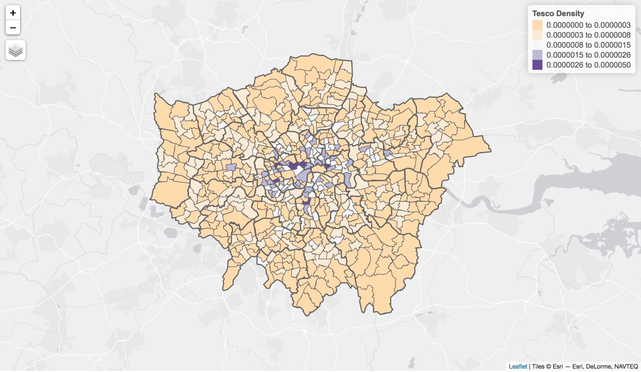

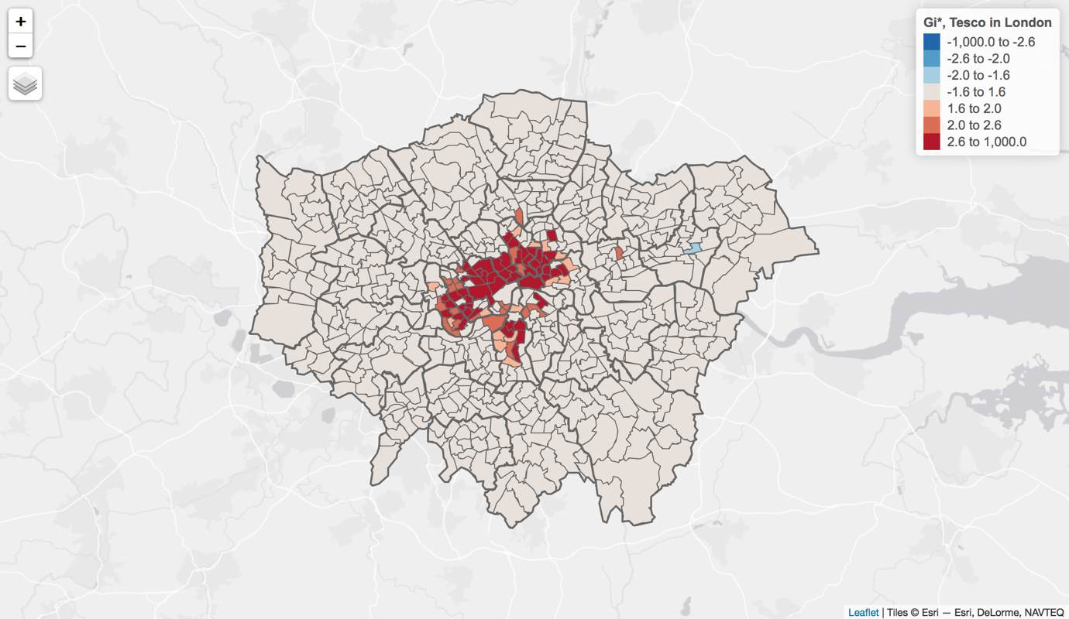

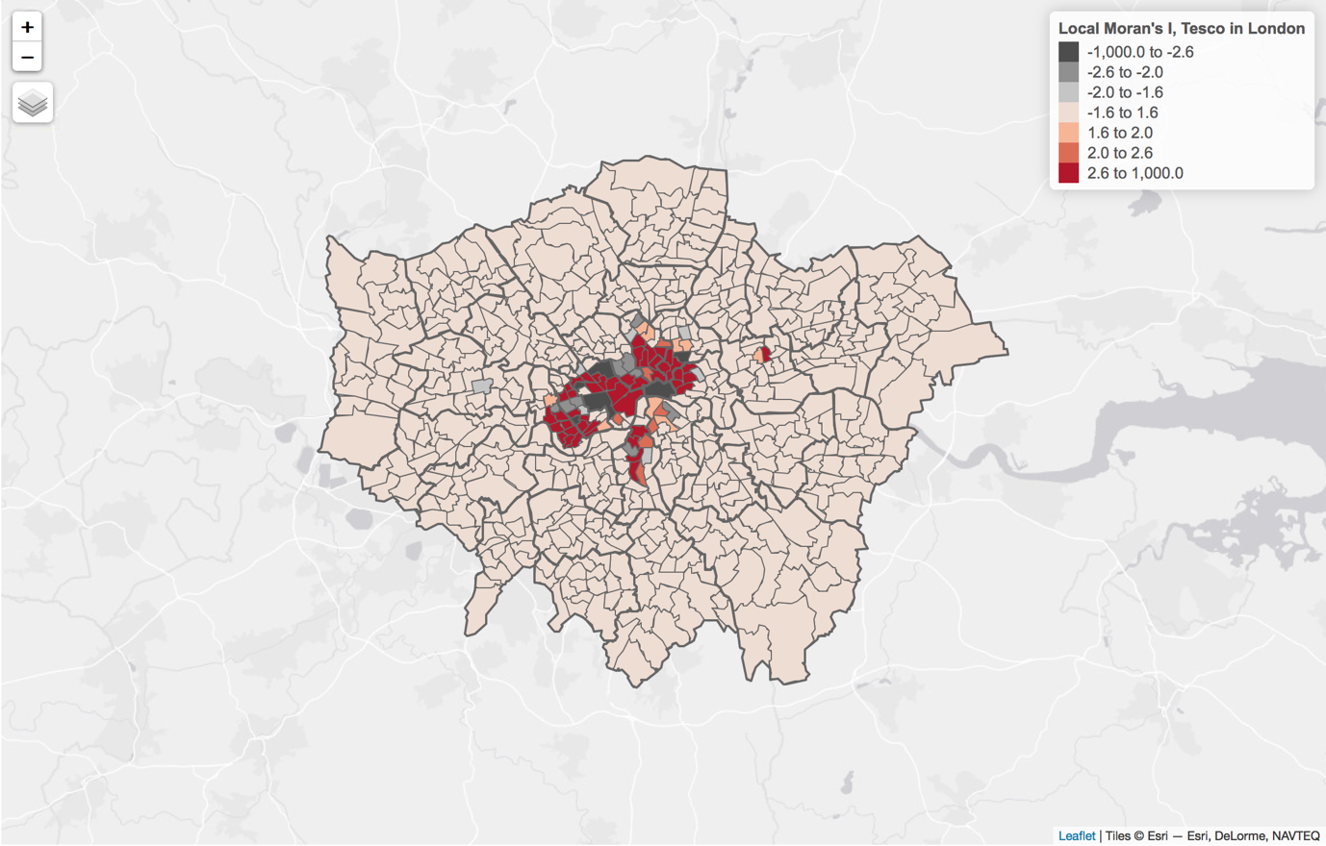

**Map made by R Studio**

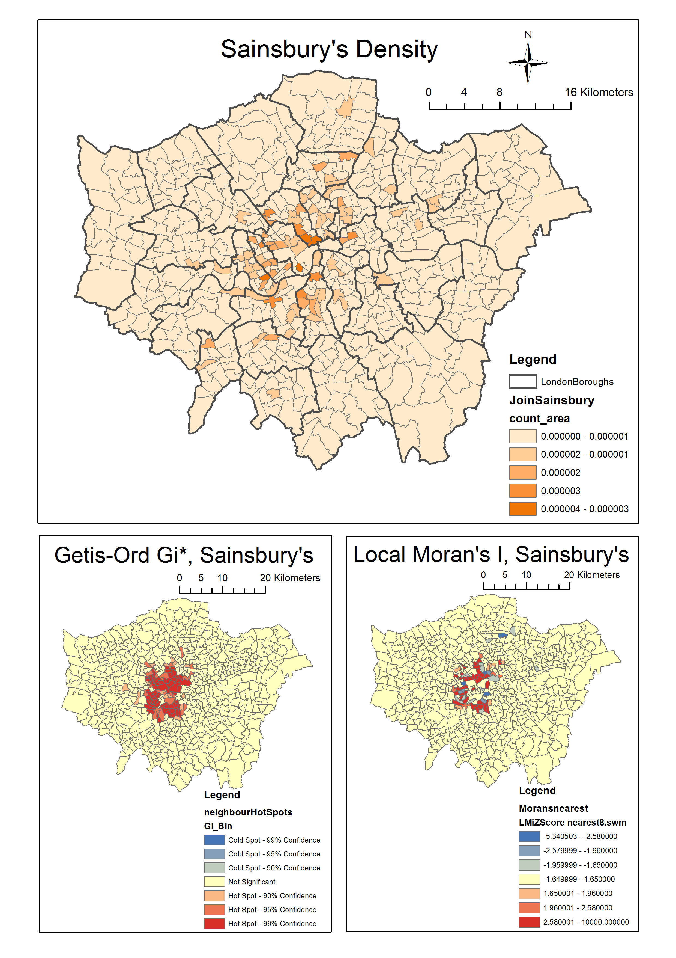

**Map made by ArcGIS**

**ArcGIS vs R Studio**

Based on my own experience through using both ArcGIS and R Studio, I think ArcGIS is much more user-friendly and convenient for programming novices as it has systematically pre-created tools and technical support. Even if you are new for ArcGIS, you can speculate the function of each button from its name and icon, and you can find how to use this function and its principle very detailed by just searching in ArcGIS Resource website which provide the complete instructions in many different kinds of language. While for R Studio, you may find it’s really hard to learn it systematically as it has countless packages and the code and logic within them are always different. On the other hand, R Studio has many advantages, for example, it’s more customized, scalable and open as it’s free. If you want to do more advanced and complex analyze beyond ArcGIS’s frame, you can write it in R Studio by yourself and there are so many hobby friends on the Internet to talk and share codes. Also, I think ArcGIS is more suitable to make traditional static map and the layout view is quite handy for typesetting, whilst R Studio is expert in making interactive maps. As we become more familiar with packages and codes, I think we will use R Studio more as it's freer and typing codes sometimes is quicker than clicking mouse!

**Part 2 - Spatial Analysis Challenge**

I choose to use ArcGIS because when I read these questions, I can immediately figure out how to solve them by ArcGIS, but for R, it may take a long time to search for the suitable packages and codes.

First of all, drag LondonWardsNew.shp into ArcMap as the base map and check the coordination system of it is BNG, and merge the city of London wards into a single zone as appendix says. Then, drag Placemark Point in London stations.kml into the map and export data as shapefile. When check the coordination system of it, find it was WGS 1984, so use “project” tool to transfer as below shows.

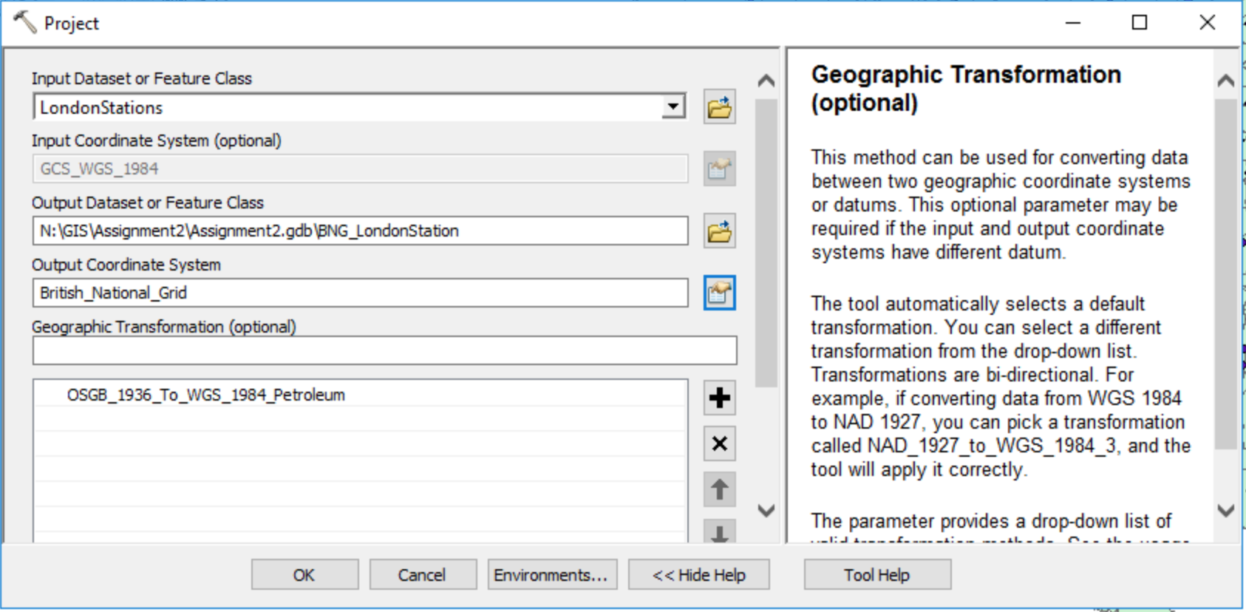

The same procedure to deal with the hunt address and Team7 trace, though there is a mistake in huntaddresses.csv. The location of Platform 9 & ¾ is wrong! Change it in the csv before “display XY data” because if changing it in the layer attribute table through “edit” directly, the point still cannot show up. Finally, every layer’s coordination system is BNG like below shows.

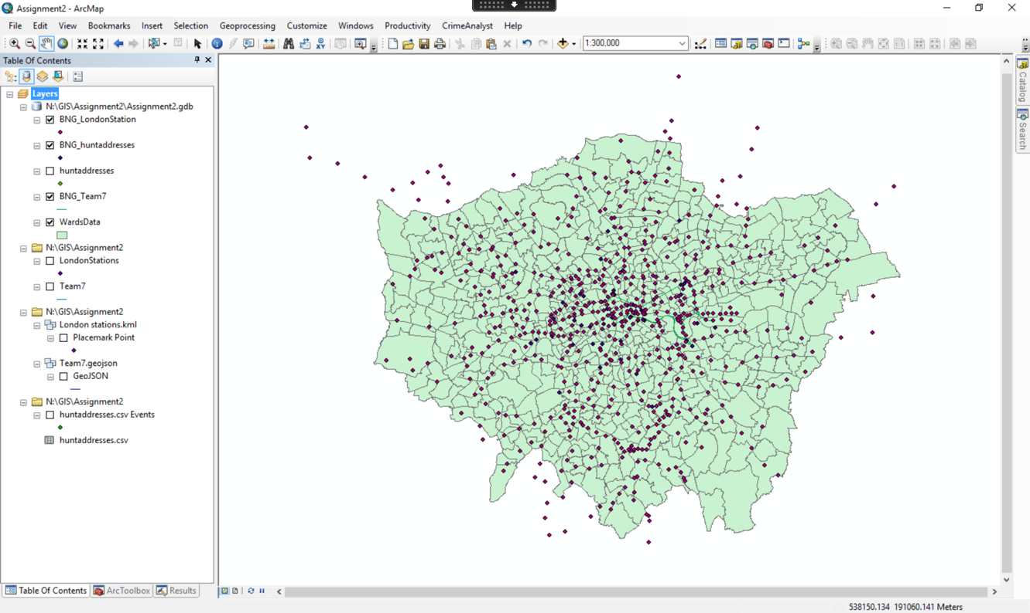

Question 1: to answer this question, right click BNG_Team7 layer and choose “open attribute table”, and in the table, we will find the trace length has been calculated automatically as “Shape_Length” shows when doing the projection transformation. But for double check, add a new field in the table called “trace_length” and right click the header and choose “Calculate Geometry” to calculate the length, and the result is the same – 46603.95m.

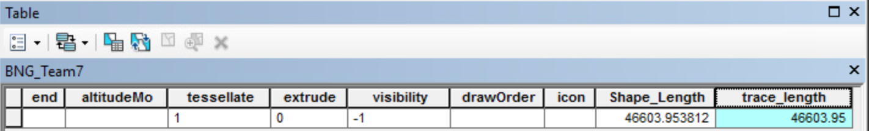

Question 2: to get answer more quickly, use “Spatial Join” tool in ArcToolbox -> Analysis Tools -> Overlay, set “Search Radius” as 100 meters so that it can include the stations within 100 meters from the trace. We can set “Join Operation” as JOIN_ONE_TO_MANY, if we want the information of every joined station, while we can also choose JOIN_ONE_TO_ONE, if we only need to know the counts. We can also use “buffer” and then “intersect” to answer this question, but it’s slower because more operations need to be done.

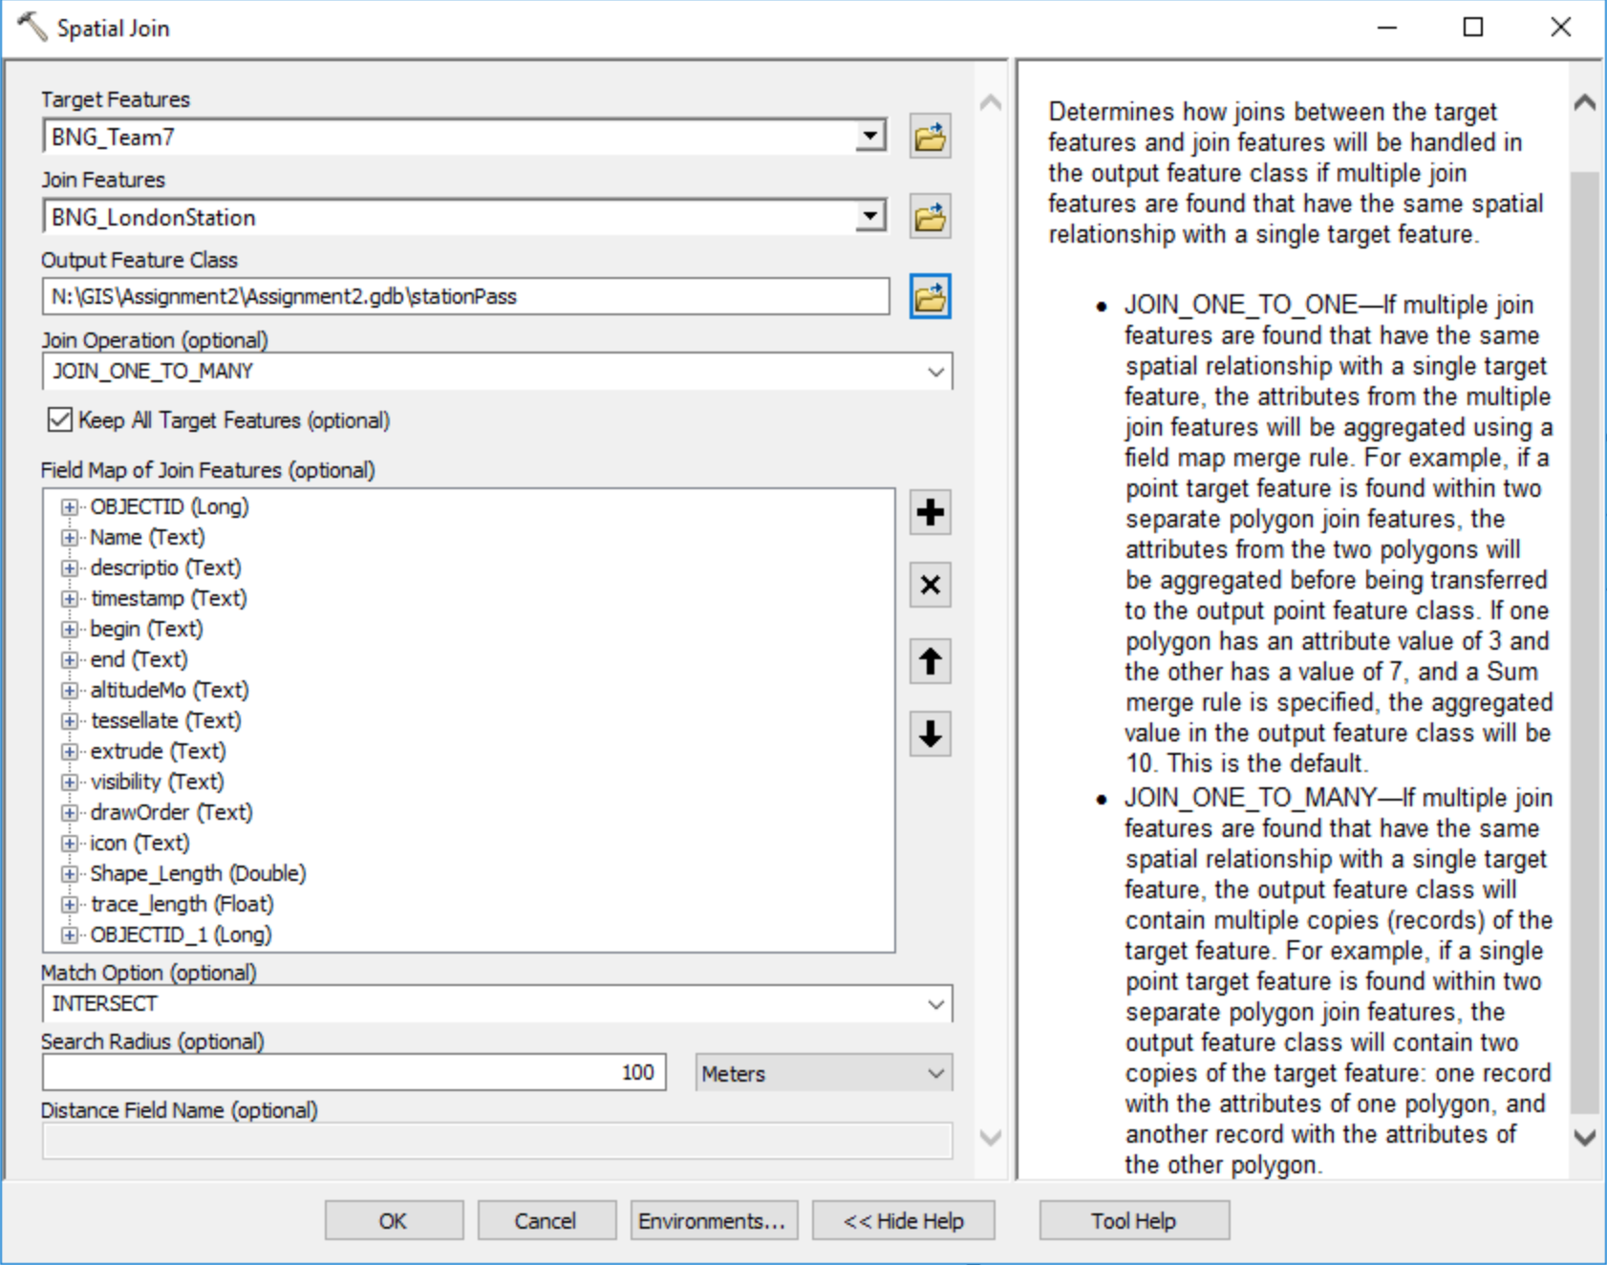

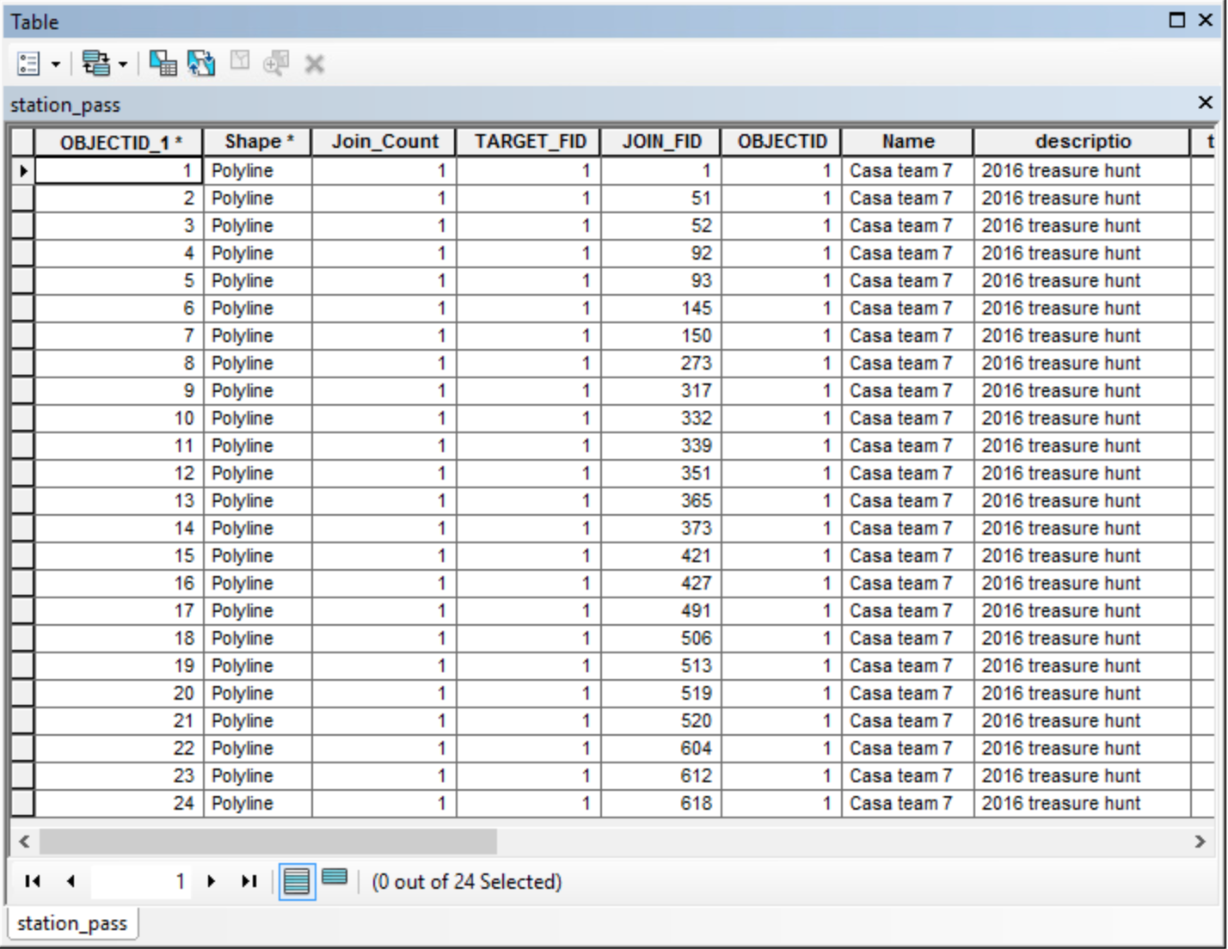

The Attribute Table When choosing JOIN_ONE_TO_MANY

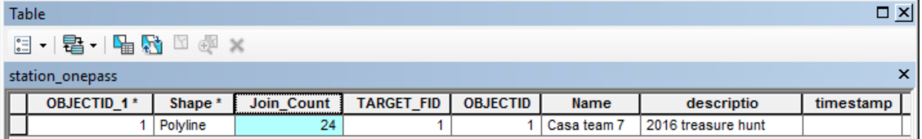

The Attribute Table When choosing JOIN_ONE_TO_ONE

Question 3: The briefest and quickest way is using “spatial join” and setting like below, and the result is 62 points.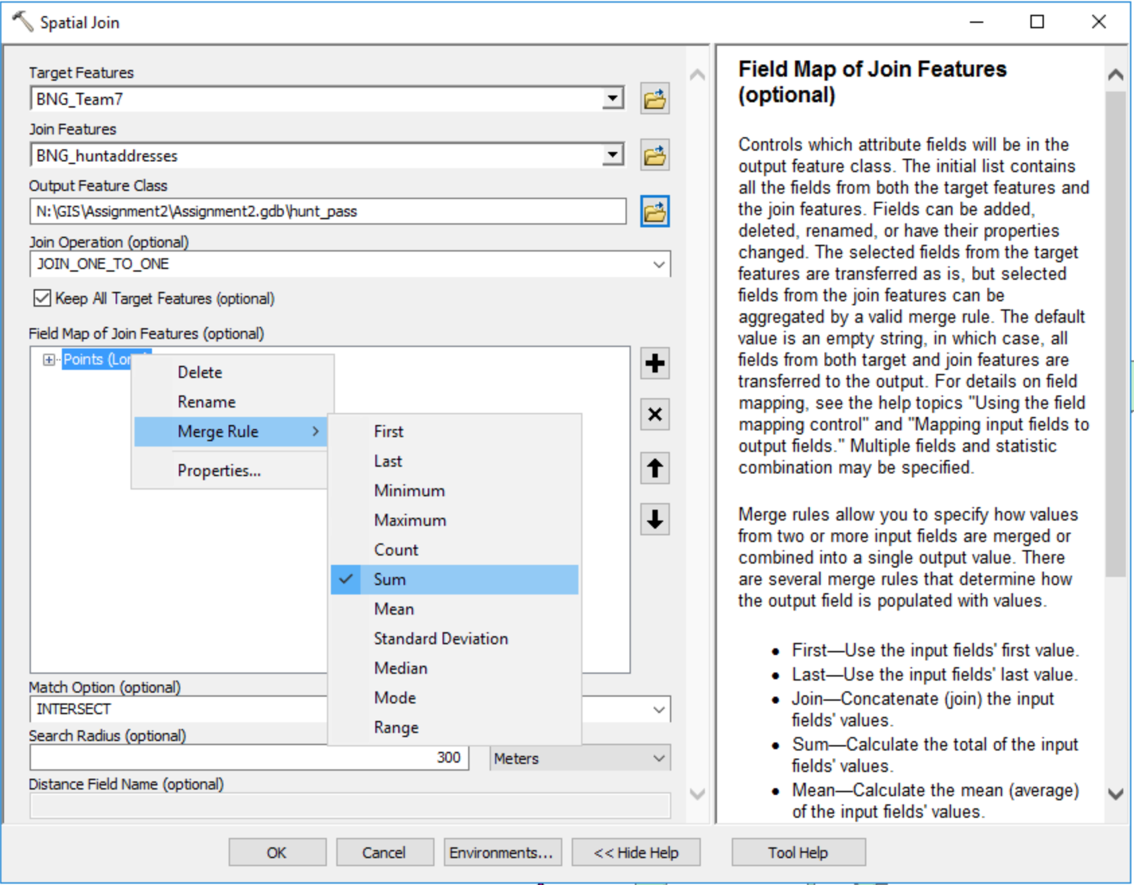

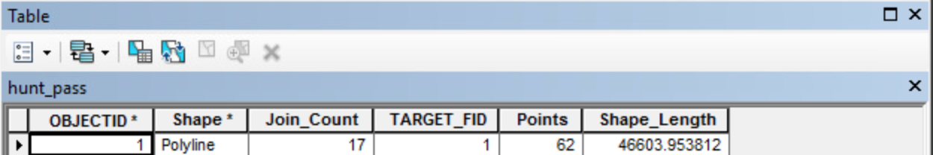

Question 4: use “intersect” in processing, then open the intersected layer’s attribute table, use sort ascending from low to high to male life expectancy column, and the first line shows Weavers had the lowest while city of London had the highest.

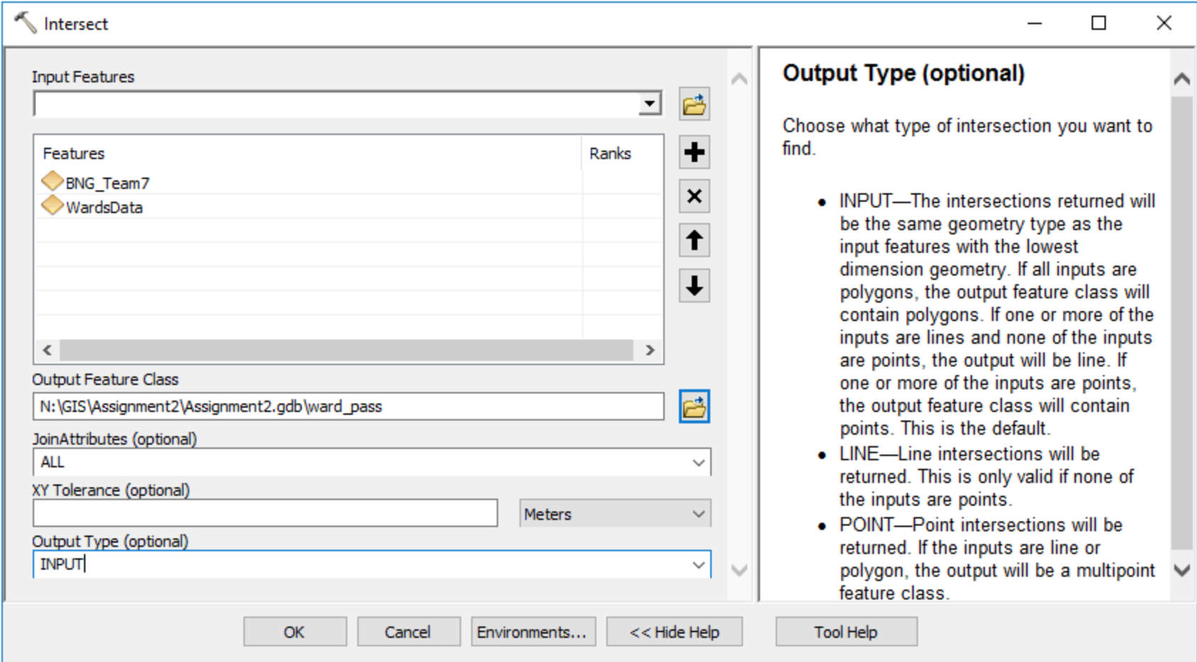

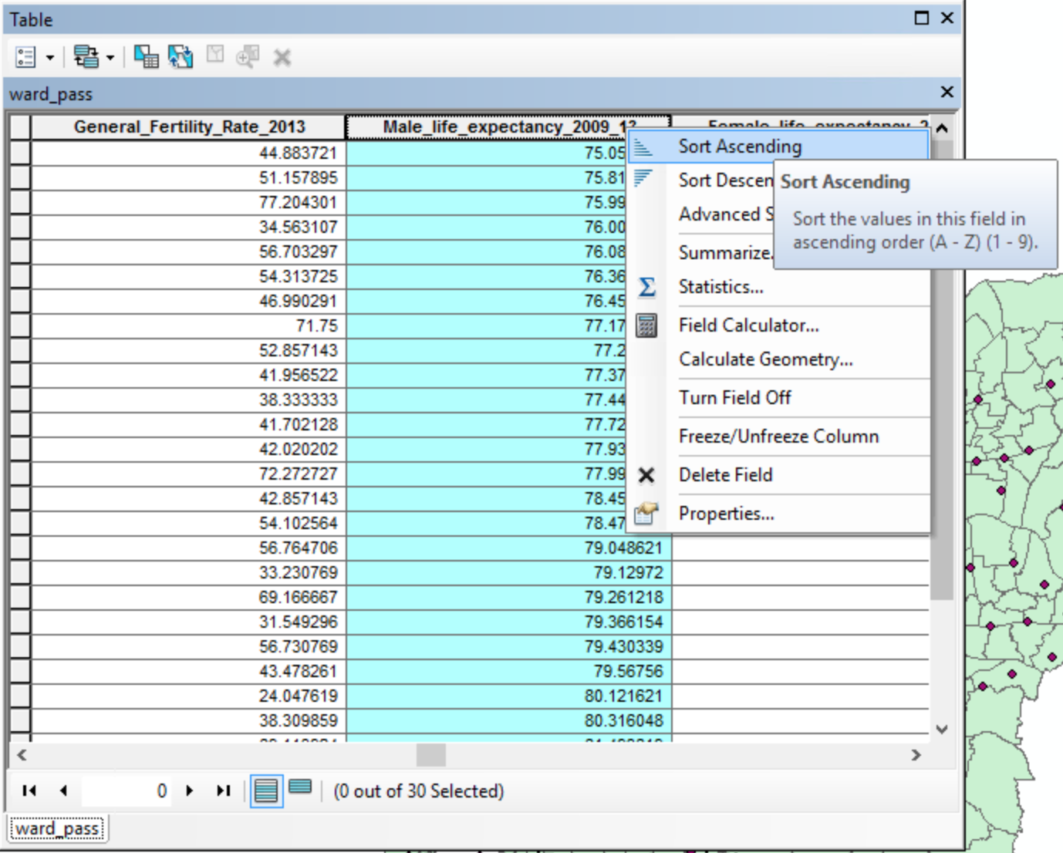

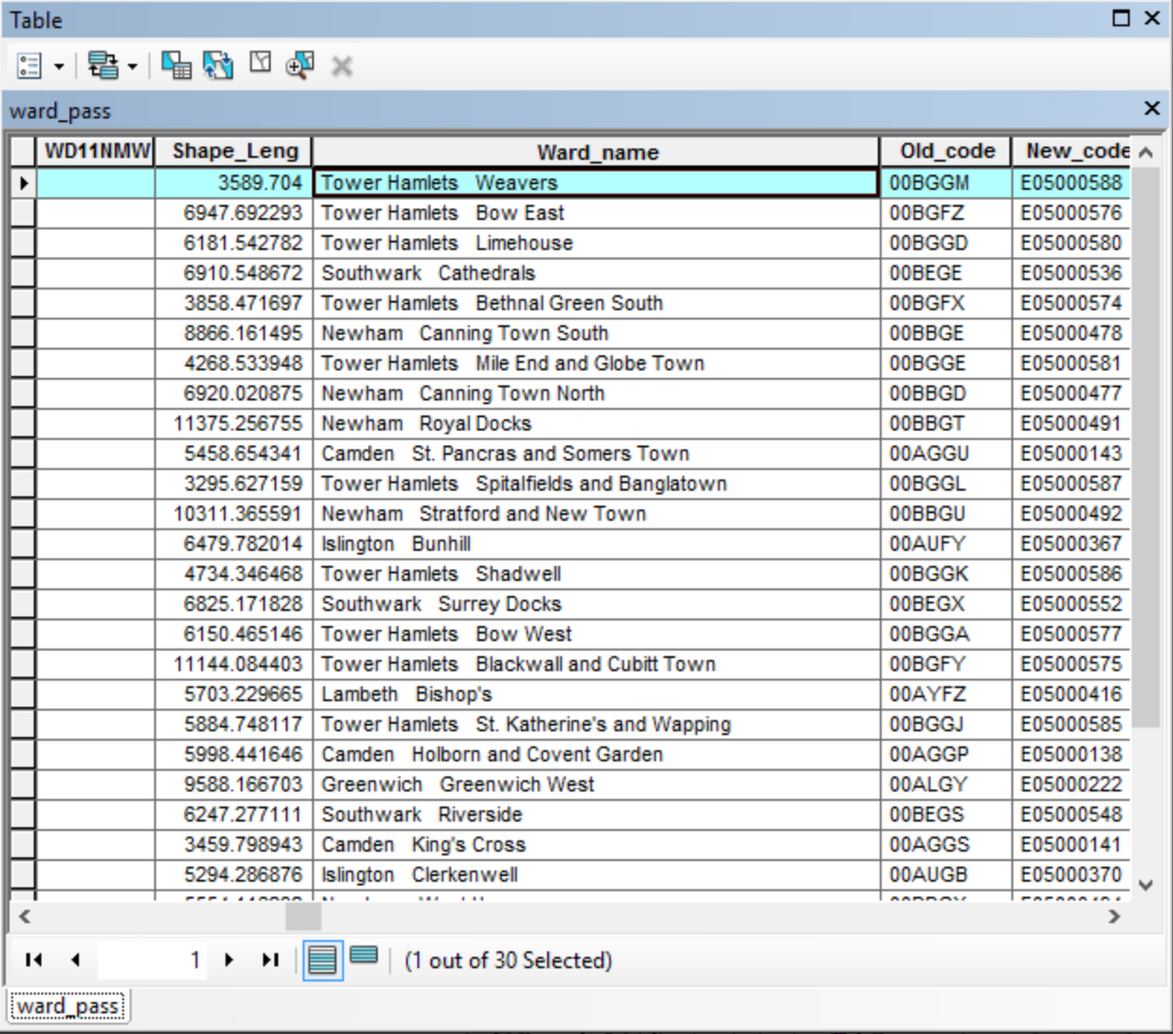

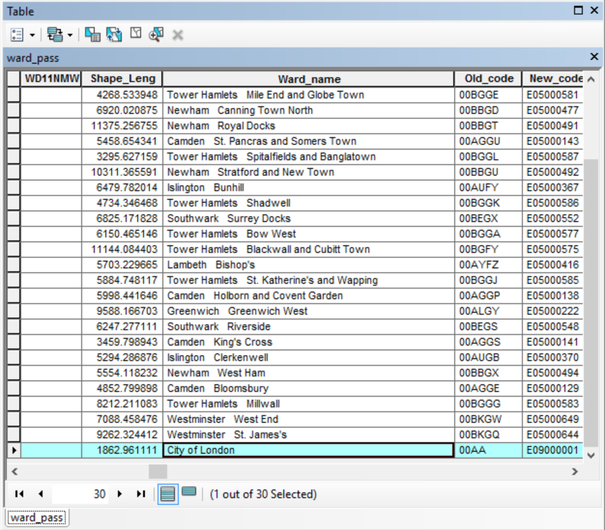

Question 5: add new field in intersected layer, and calculate the average of male and female’s life expectancy, then view the statistic table and find the mean of all wards’ life expectancy is 81.43.

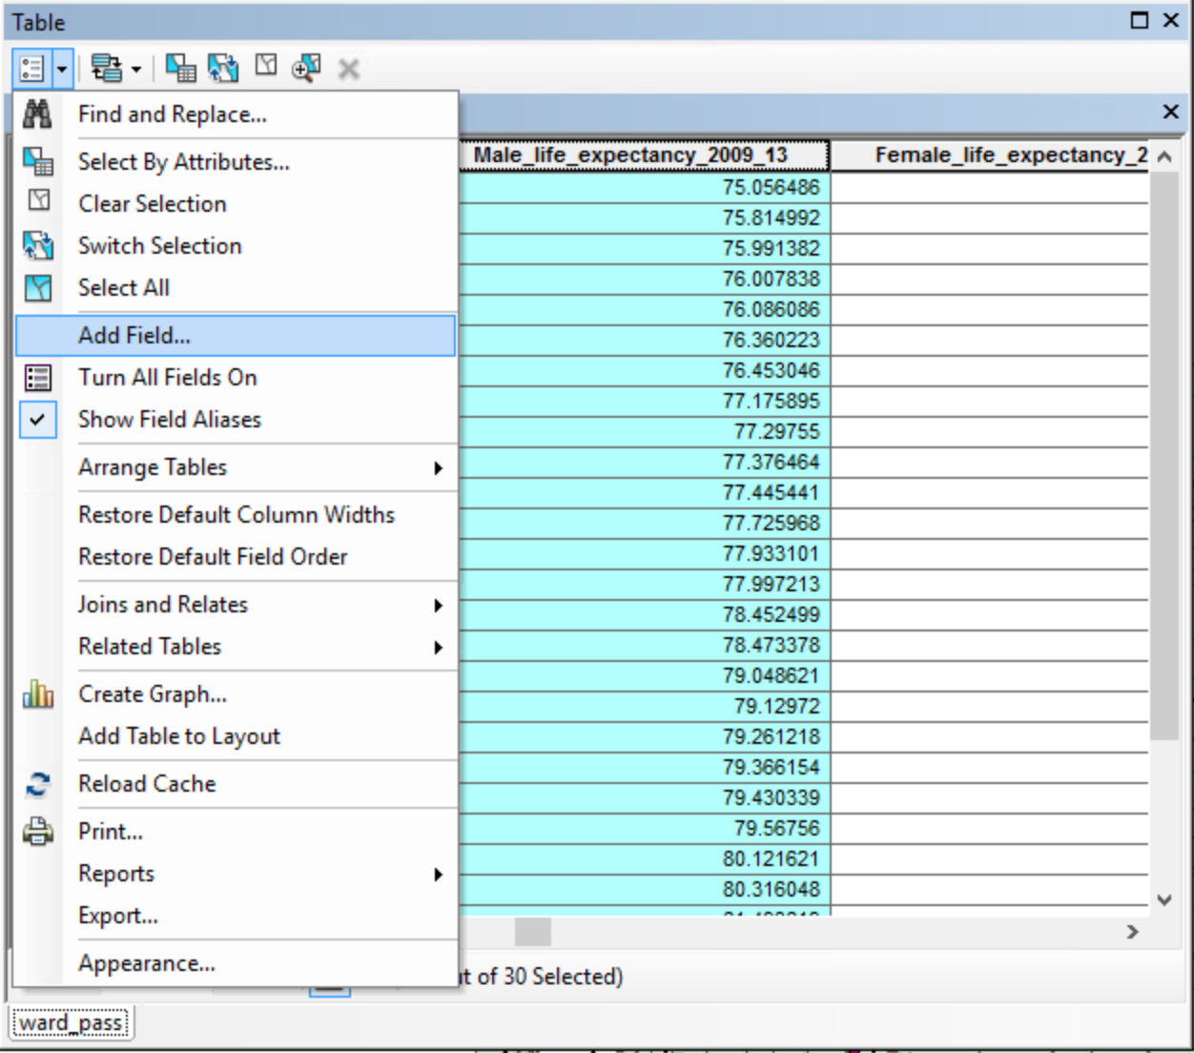

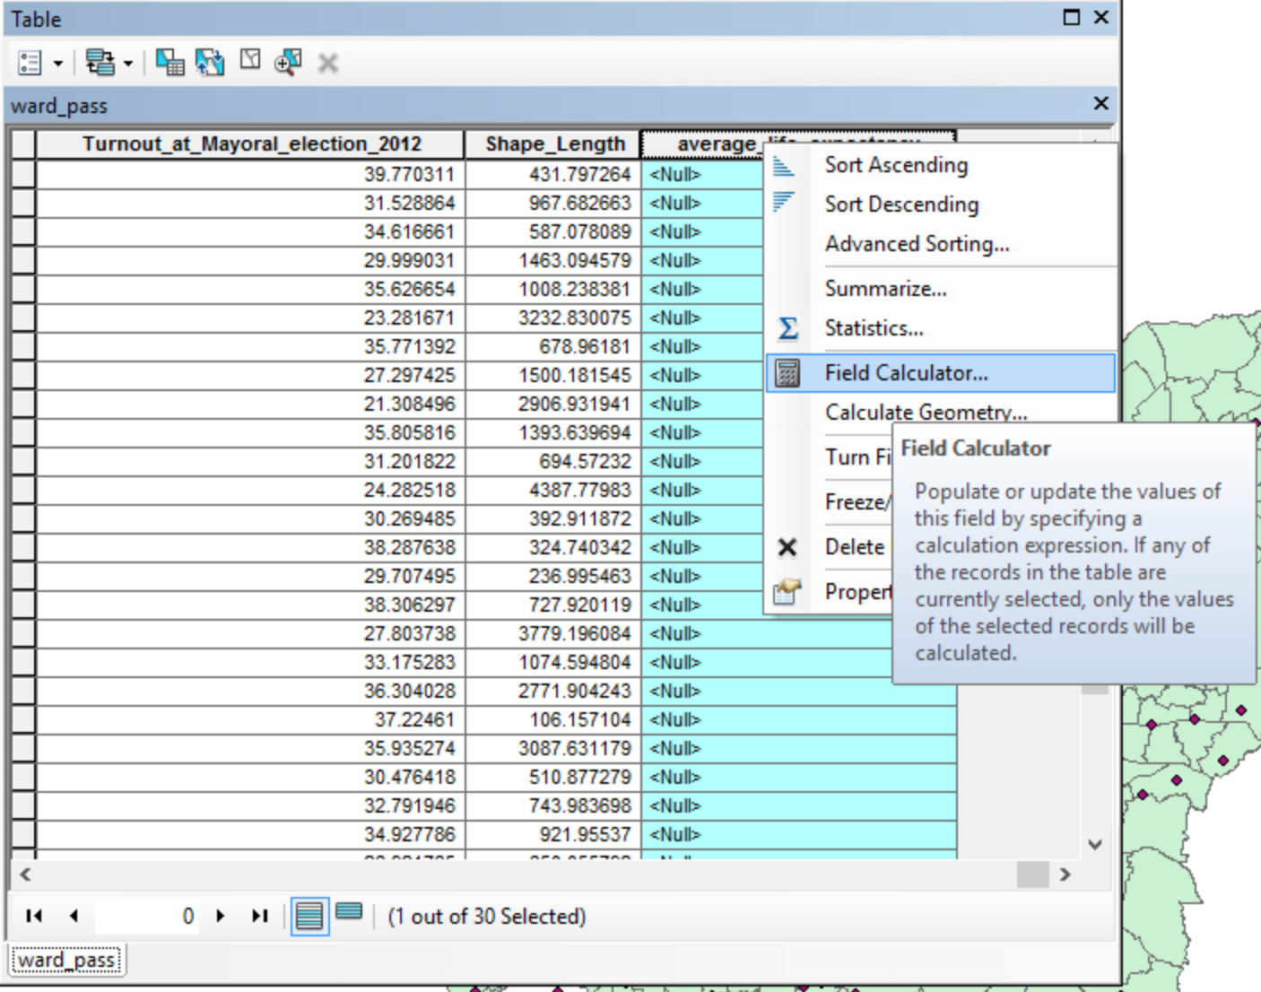

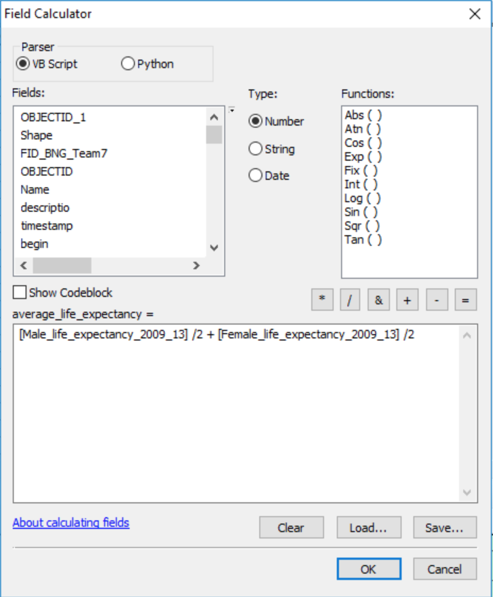

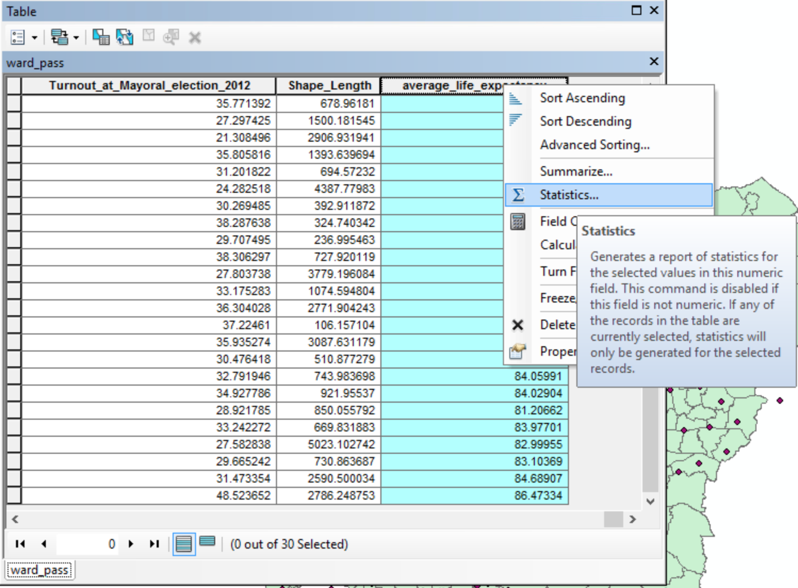

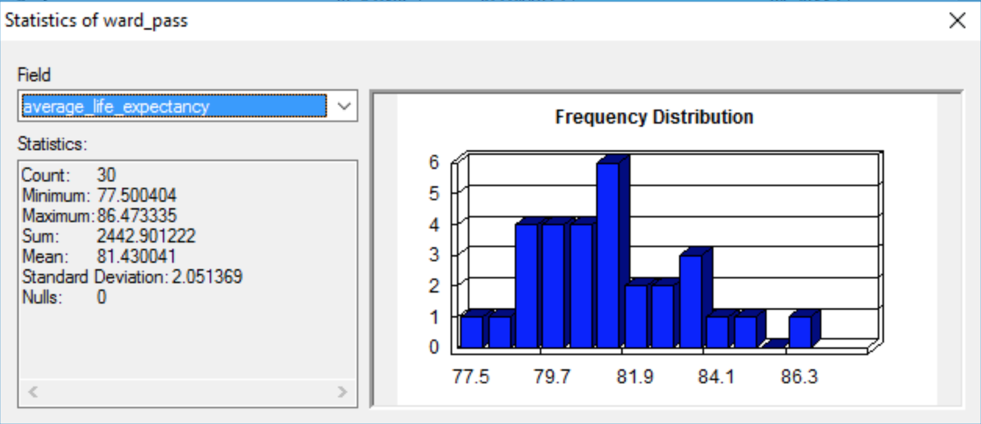

Question 6: use “Multi-Distance Spatial Cluster Analysis (Ripley's K Function)” in ArcToolbox -> Spatial Statistic Tools -> analyzing patterns. The observed K is always above the Expected K means the distribution of hunt addresses is clustering.

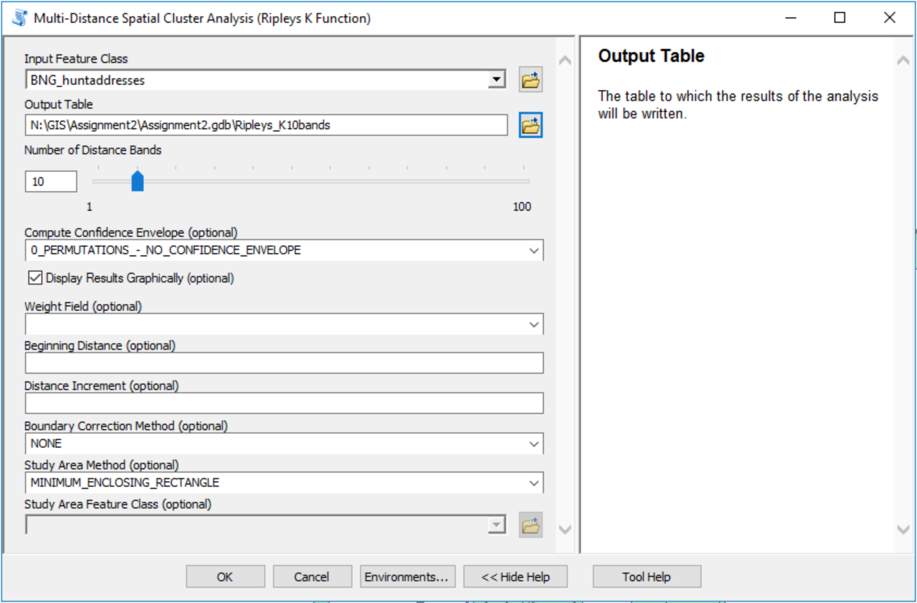

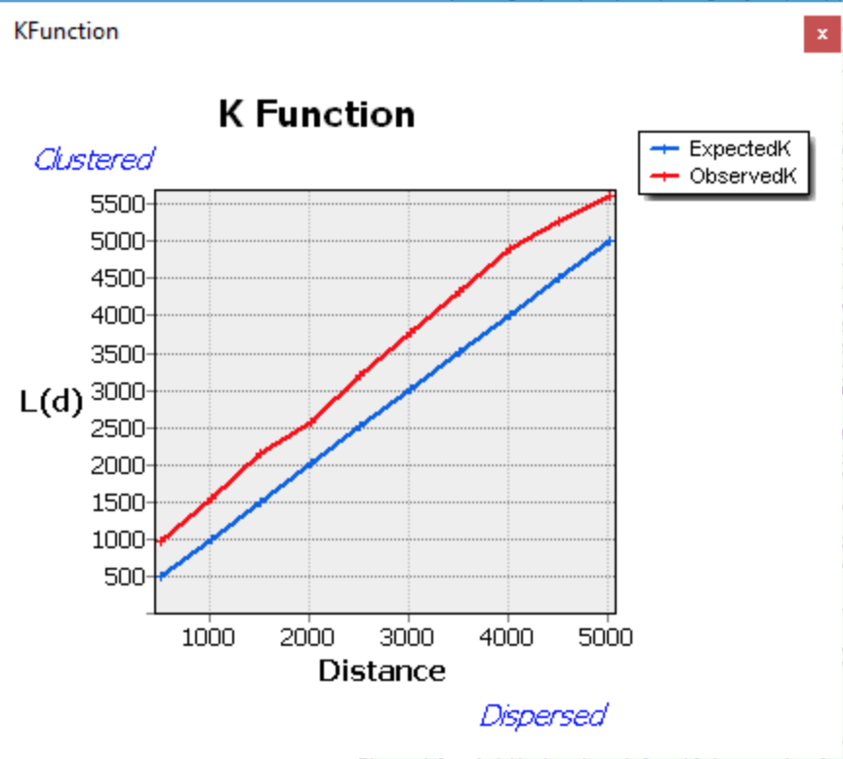

Ripley's K Function in 10 Distance Bands

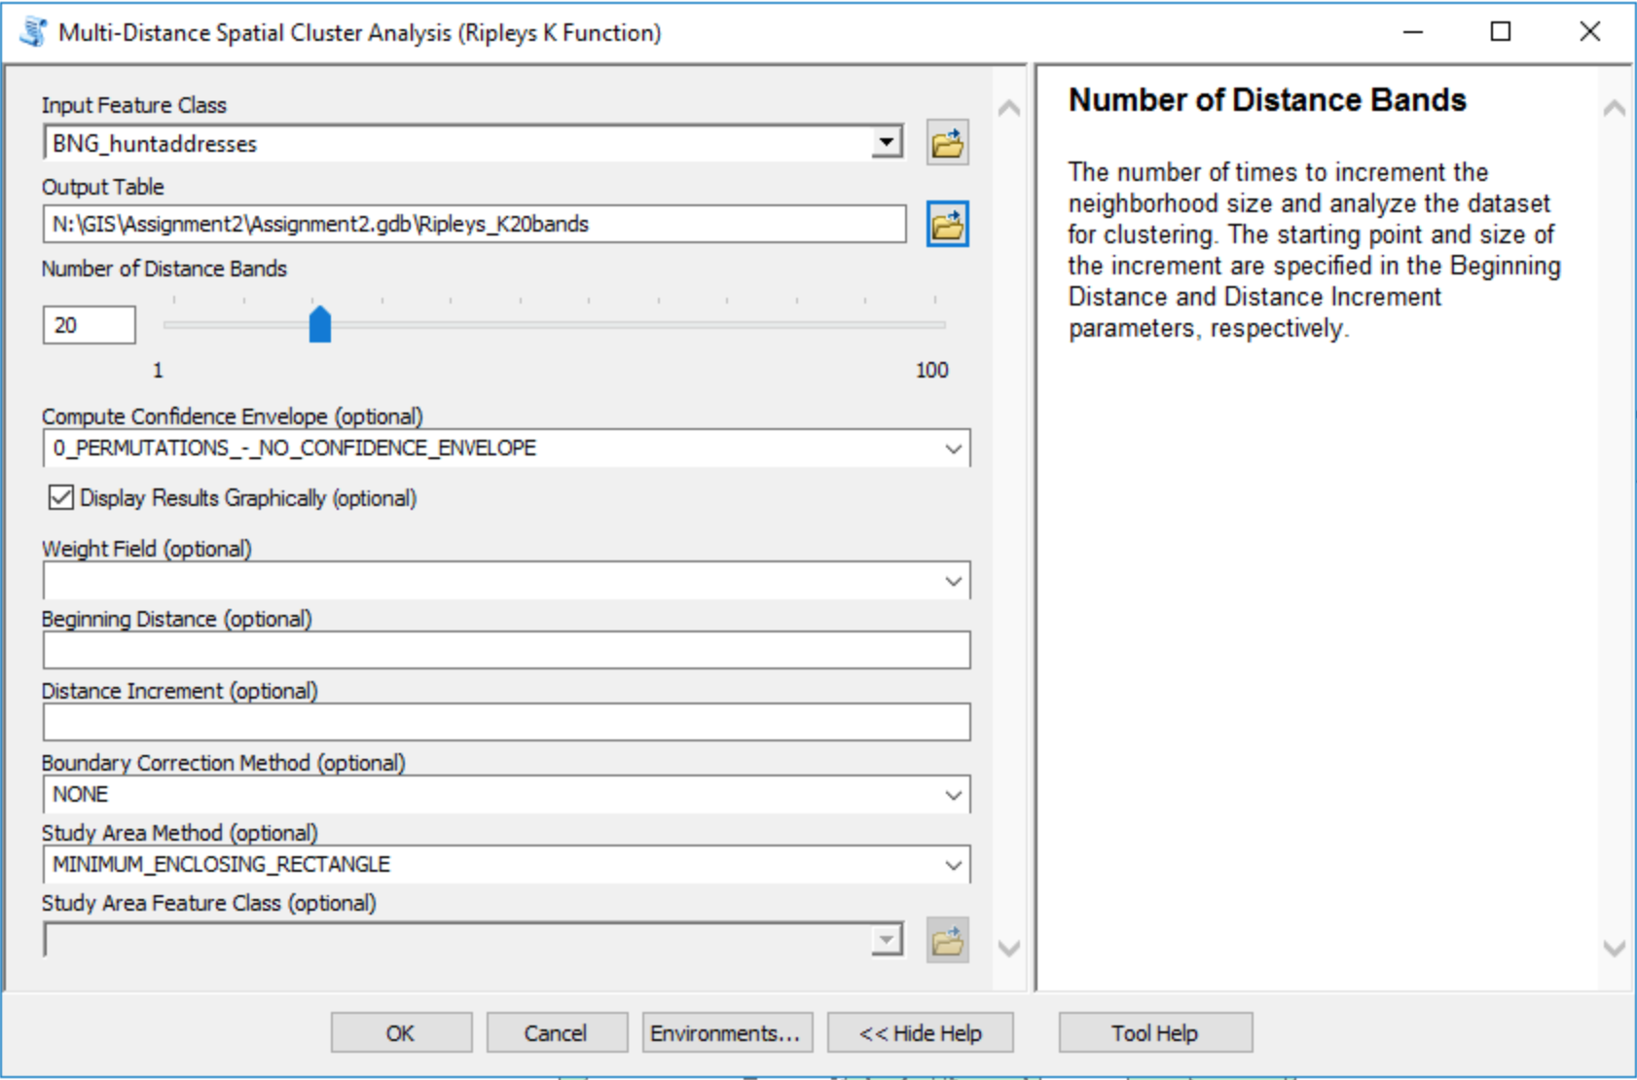

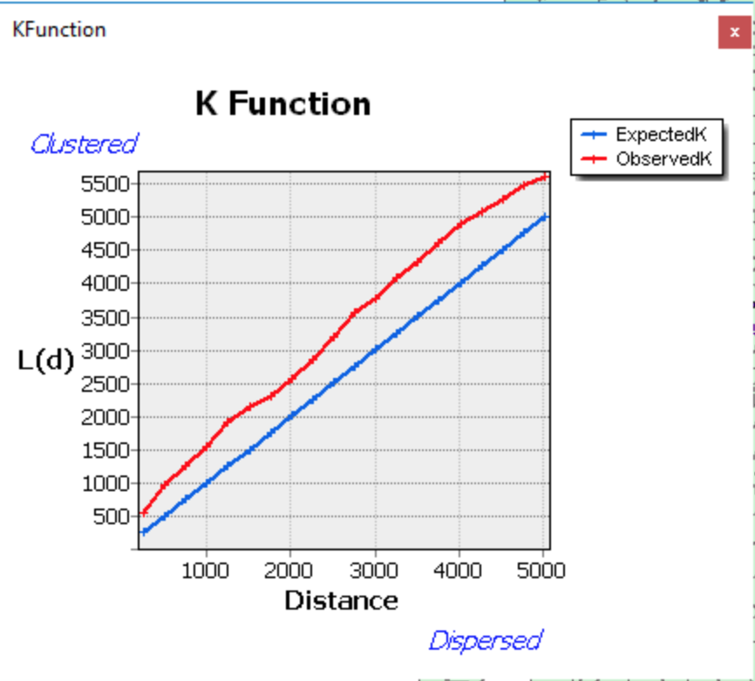

Ripley's K Function in 20 Distance Bands

Uncertainty: for raw data: there may be some mistakes in data and the survey data and the trace recorded by GPS may also have deviation; for representation: the transformation in different coordinate systems will result in inaccuracy; for analysis: for Ripley's K, setting different number of distance bands, compute confidence envelope, study area method and so on will all influence the result. With changing the number of distance bands from 10 to 20, the clustering shown on the table becomes weaker in close distance.

**Part 3 - Mini Project. 1800 word report**

When riding a bike in London, we will find there are so many roads without the cycleway. You have to ride your bicycle very carefully because cars are probably just following you or passing you in very close distance. Whether the length of the cycleway has the relationship with the cycle accidents happened in every ward in London? It’s the research question of this mini project. We set H0 = The density of the length of the cycleway in every ward in London has no significant influence to the density of cycle accidents in wards, while H1= The density of the length of the cycleway in every ward in London has significant influence to the density of cycle accidents in wards.

**Data Source:** The data for the coordination of every traffic accident happened in 2017 is obtained from <http://content.tfl.gov.uk/2017-data-casualty.csv>. The shapefile of all kinds of roads in London is downloaded from <http://download.geofabrik.de/europe/great-britain/england/greater-london.html>, and the original source is from OpenStreetMap. Ordnace Survey also provides open road map, but unfortunately, it doesn’t contain cycleway in its classification system. Though the data from OpenStreetMap are donated by personal users which may have bigger deviation than the data from the government or consortium, it may be the only shapefile containing the cycleway which is open for the public. The London ward boundaries are downloaded from moodle but can also be acquired from London Datastore and many other websites easily.

**Software Choosing:** It’s a simple linear regression question and ArcGIS already has the “Ordinary Least Squares” tool in ArcToolbox -> Spatial Statistics Tools -> Modeling Spatial Relationships which can solve this question well and produce statistic file automatically. Therefore, I choose to use ArcGIS to do this research.

**Raw Data Transformation:** To reduce the burden of ArcMap, select only the cycle accidents which caused fatal or serious casualties by using filter in Excel, and then drag the new csv into ArcMap to display the XY events, and export as a shapefile of points. The coordination system of this CSV is British National Grid which is the same as the ward boundaries, so we needn’t to transfer the projections of the cycle accident points. While the coordination system for OpenStreetMap is World Geodetic System, we select the cycleway by attribute first and export it as a new cycleway shapefile, then transfer it into BNG to reduce operation time.

To count the number of cycle accidents occurred in every wards by using “spatial join”, choose “JOIN_ONE_TO_ONE”, and a new shapefile “join_accident” will be output which contain the joint_count column. To calculate the total length of cycleway in every ward, we use “intersect” tool first to cut the cycleways which across the ward boundary. Later, join the intersected shapefile with “join_accident” by using “spatial join” again to gain the “final” shapefile which has the sum of the cycleway length and the count of the cycle accidents in every wards. Add new fields in “final” attribute table to calculate the cycleway length density and cycle accident density by “cycleway length/shape area*1000000” and “joint count/shape area*1000000” separately. Right click “final” to find Layer Properties -> Symbology -> Quantities to make the density map as below shows.

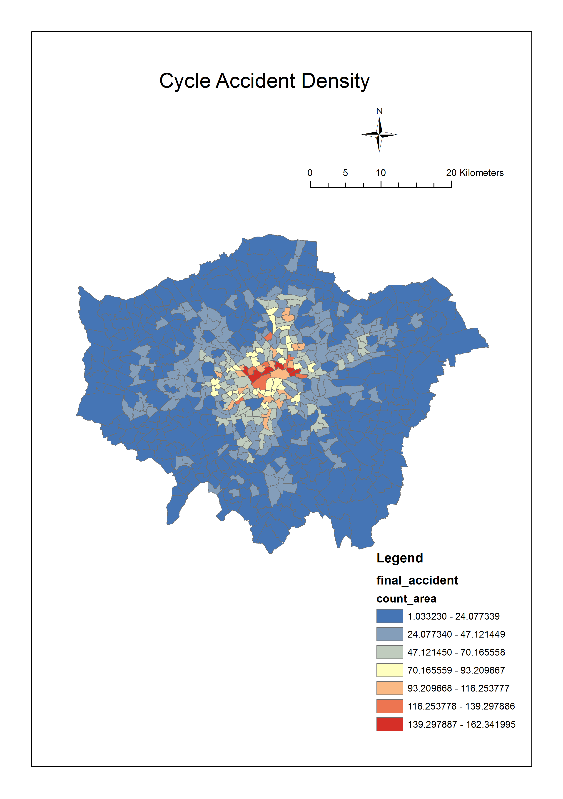

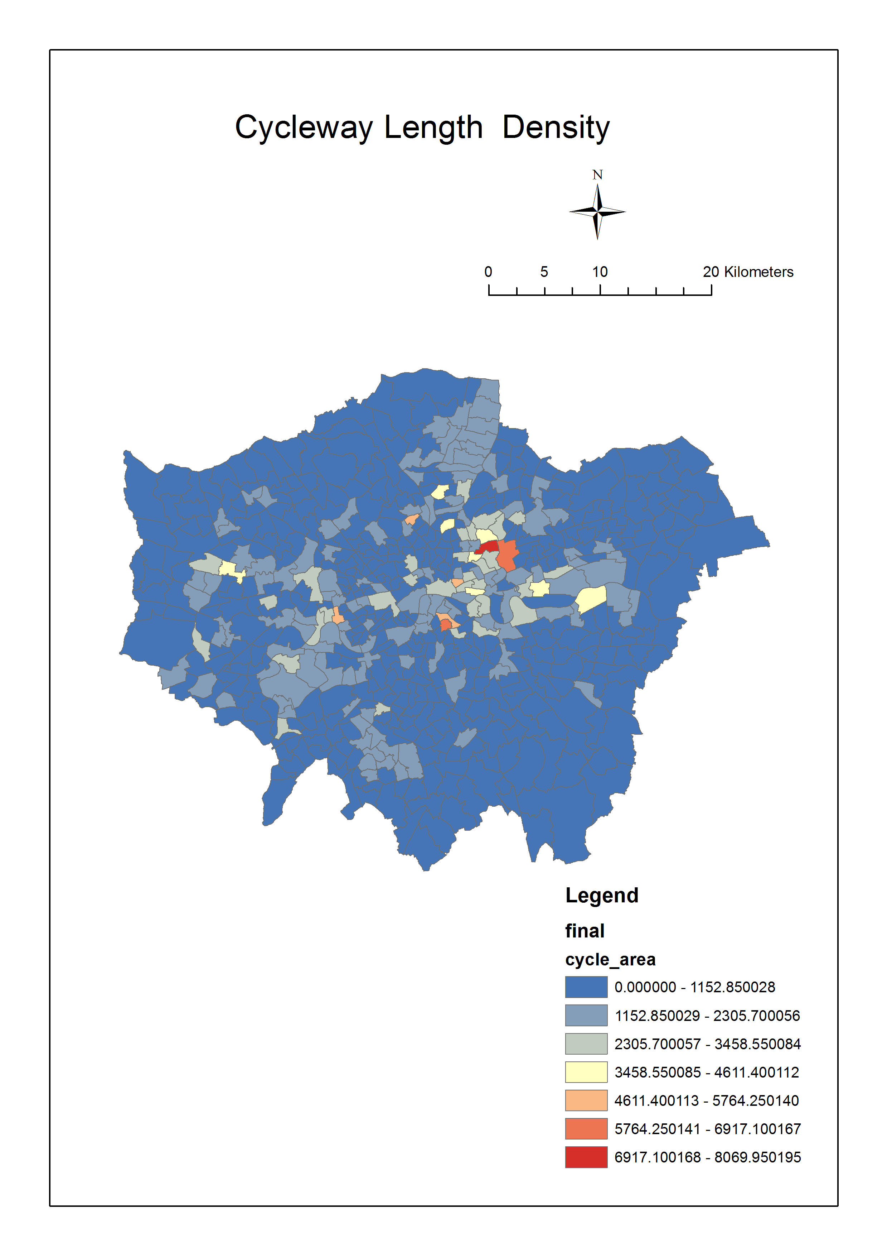

We can see both the densities of the cycleway length and cycle accidents have clustering and there are outliners in the center of London from these two maps intuitively. To prove our suppose, we can use the tool model build in practical 6 to analyze the Local Moran’s I and Getis-Ord Gi* which can reflect the clustering in local area, also add General G and Moran’s I to calculate the clustering in global area, and Ordinary Least Squares to analyze the linear relationship between the density of cycle accidents and cycleway length. After click “Run Entire Model”, all analysis will run automatically. Moreover, the model is reusable, and we can copy and change it easily. For cycle accident density clustering analysis, the Generate Spatial Weights Matrix is more suitable to be inverse distance. The influence of distance may be bigger than contiguity or neighbours, as the map above shows the further from the center, the lower the value is. But for cycleway length, the matric may be more related to neighbours. For convenience, we only compare these two densities by using inverse distance matrix. Both the p-value for high low clustering for these two densities are less than 0.01, which means the high value of them are clustering at a significant level of 0.01. As the z-score for cycle accident density is higher than the cycleway length, it’s more possible for cycle accident density has high-clustered pattern. Both the p-value for spatial autocorrelation for these two densities are also less than 0.01, which means there are clustering at a significant level of 0.01. As the z-score for cycle accident density is higher than the cycleway length, it’s more possible for cycle accident density has clustering pattern.

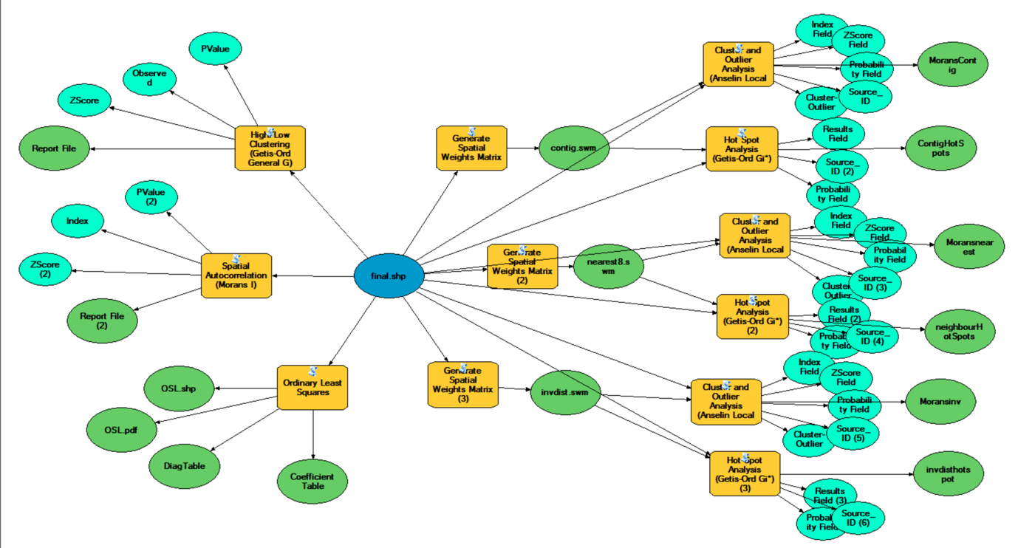

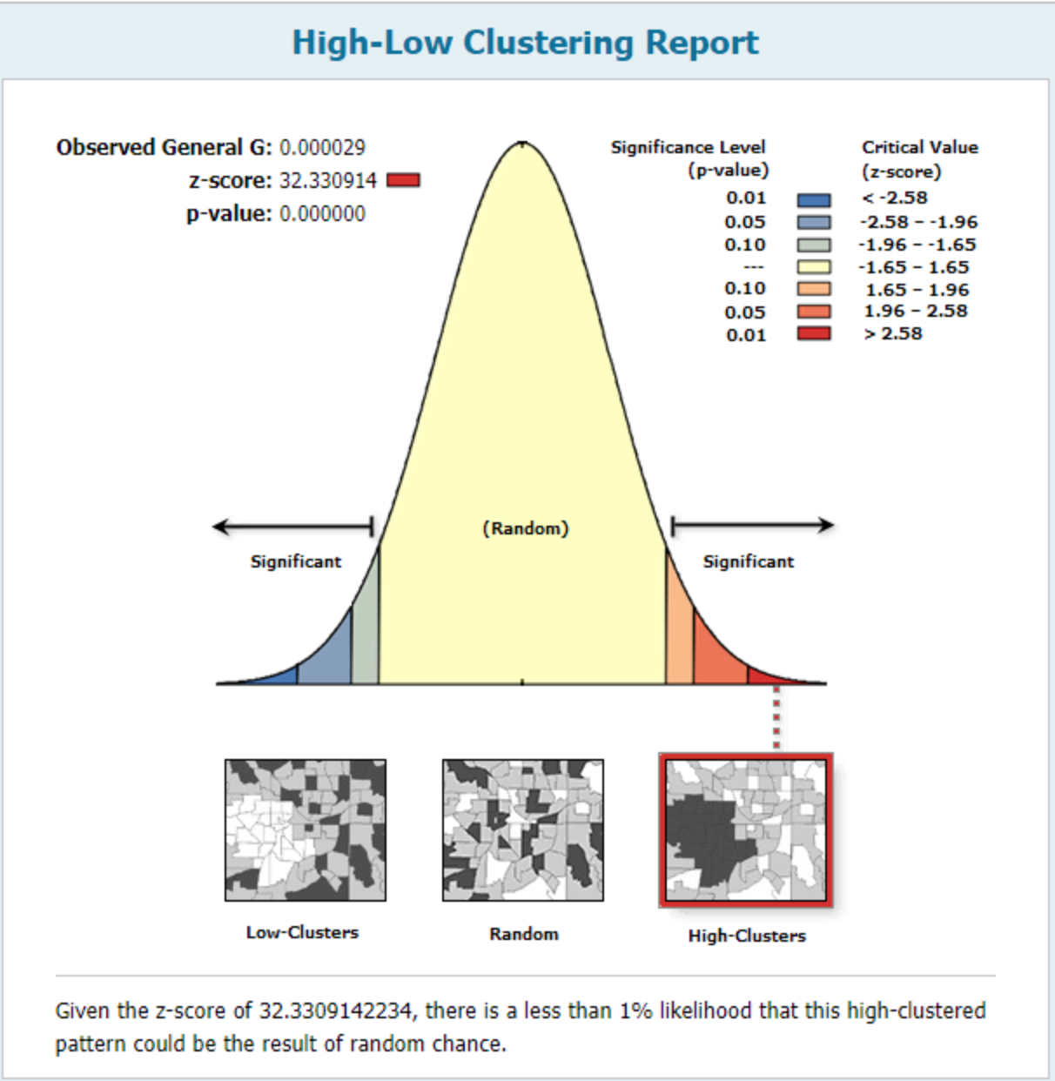

High-Low Clustering Report for Cycle Accident Density

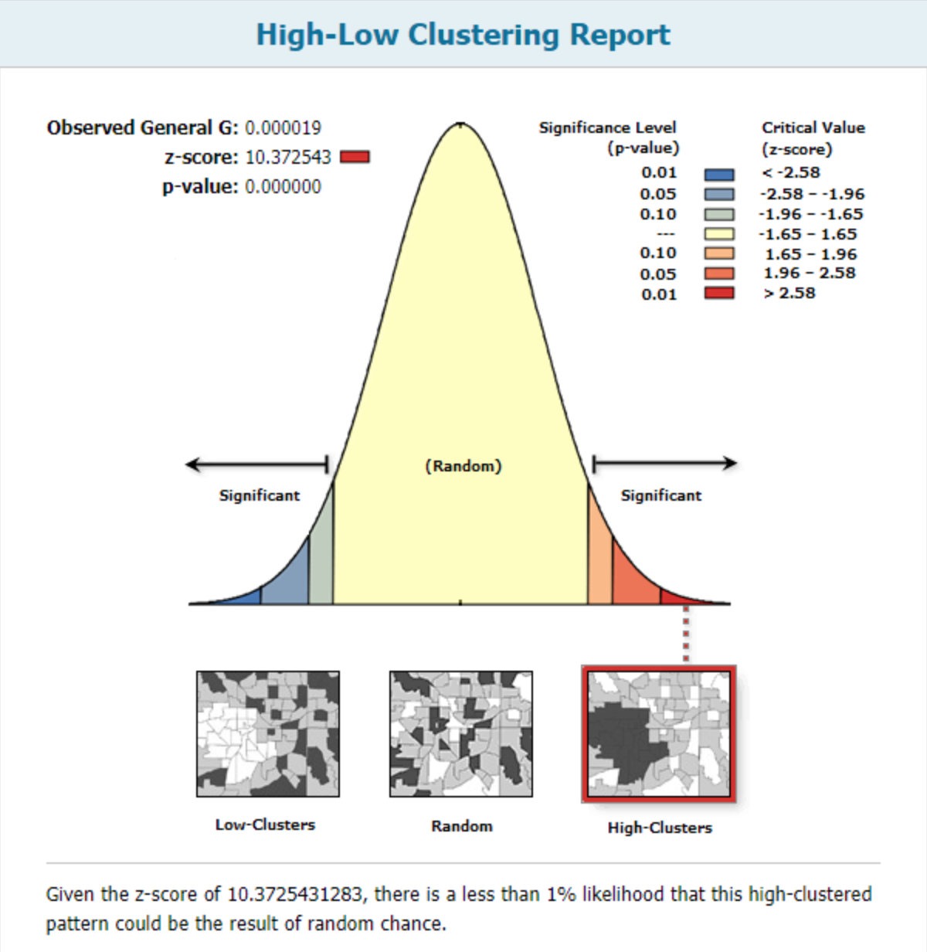

High-Low Clustering Report for Cycleway Length Density

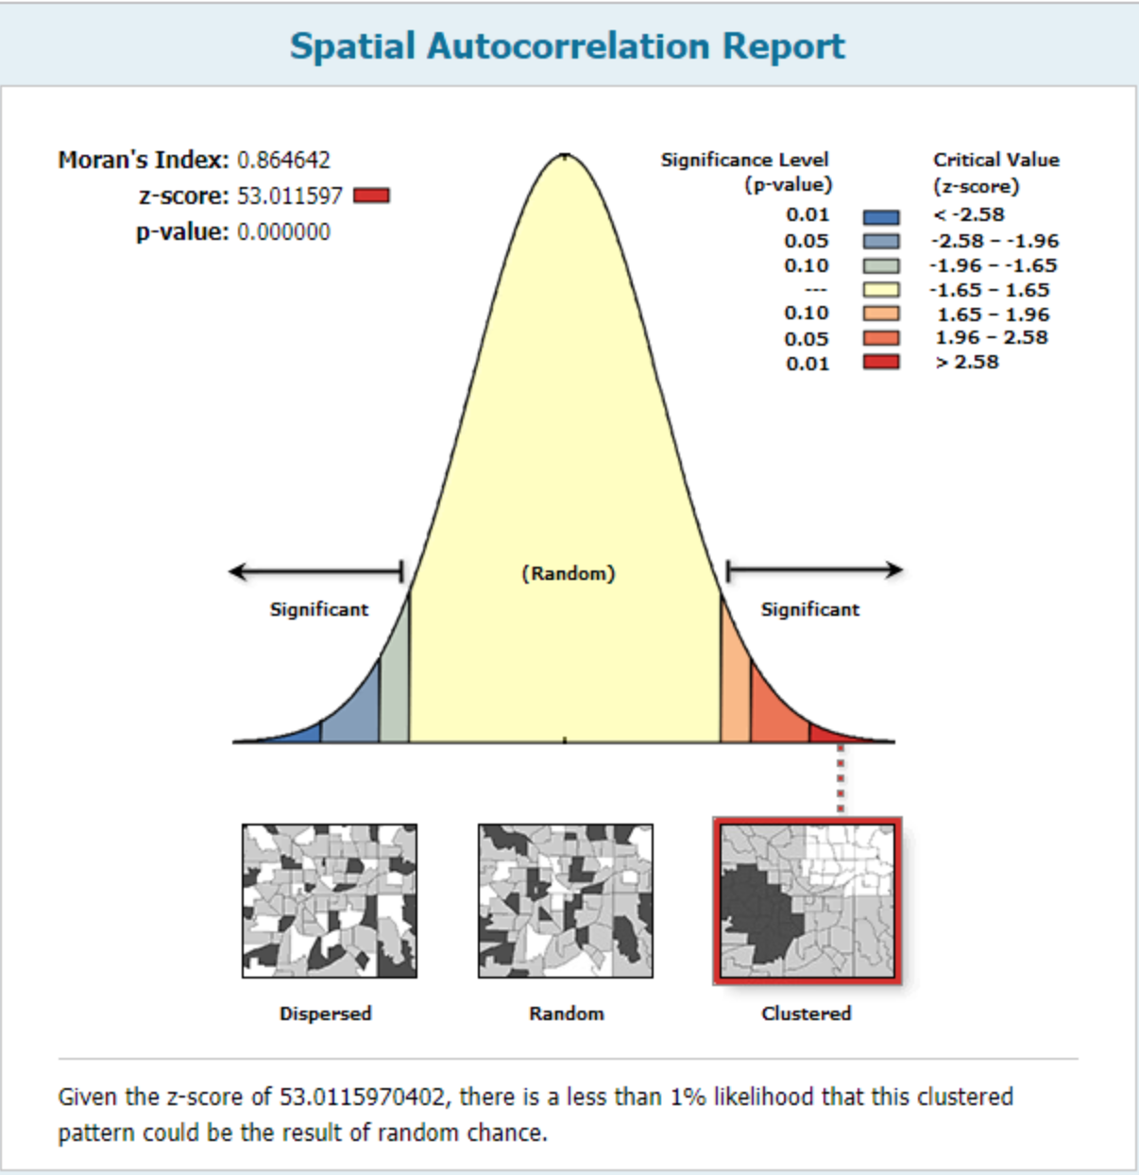 Spatial Autocorrelation Report for Cycle Accident Density

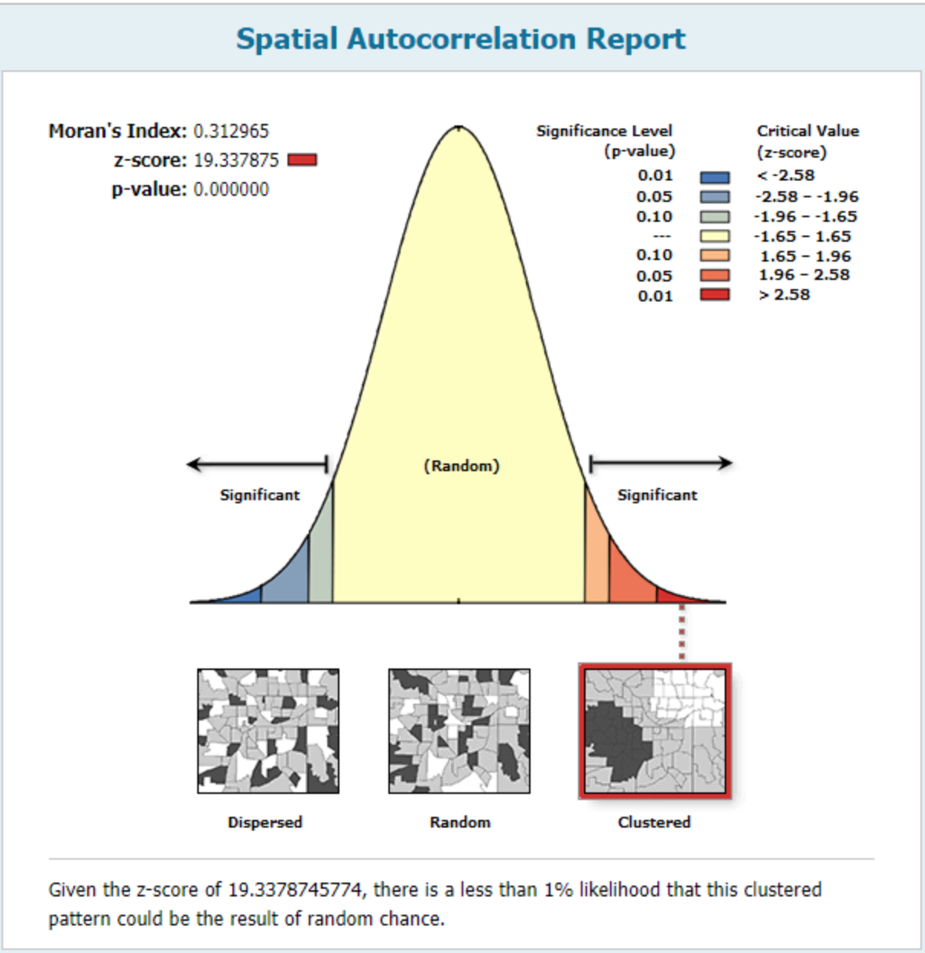

Spatial Autocorrelation Report for Cycleway Length Density

The Getis-Ord Gi* map for the cycle accident density below shows there have hot spots in the center of London in high confidence, while the map for the cycleway length density shows the hot spots may exist in the center bias to eastern of Local in high confidence, and the cold spots on the corner of London in high confidence. The Moran’s I map shows both the cycle accident density and the cycleway length density has local high-high clustering in the center of London in high confidence, whilst the cycleway length density also has low-low clustering on the corner of London. Through comparing clustering pattern of these two density, we find there has many similarities but also many differences.

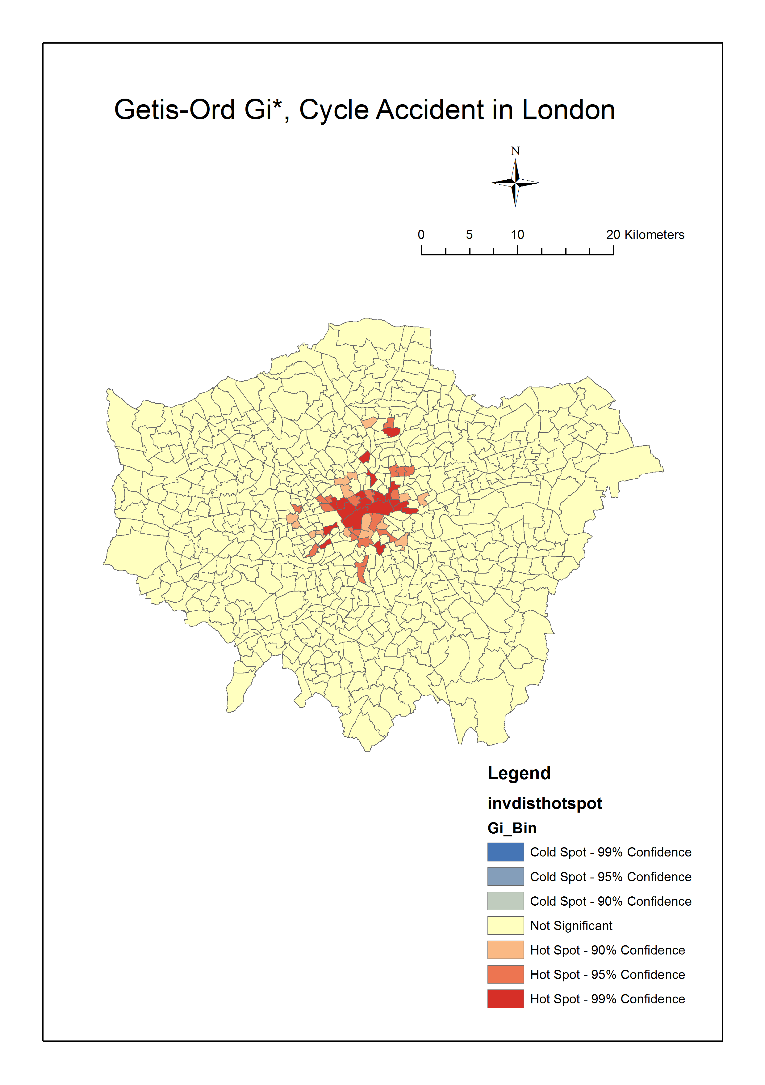

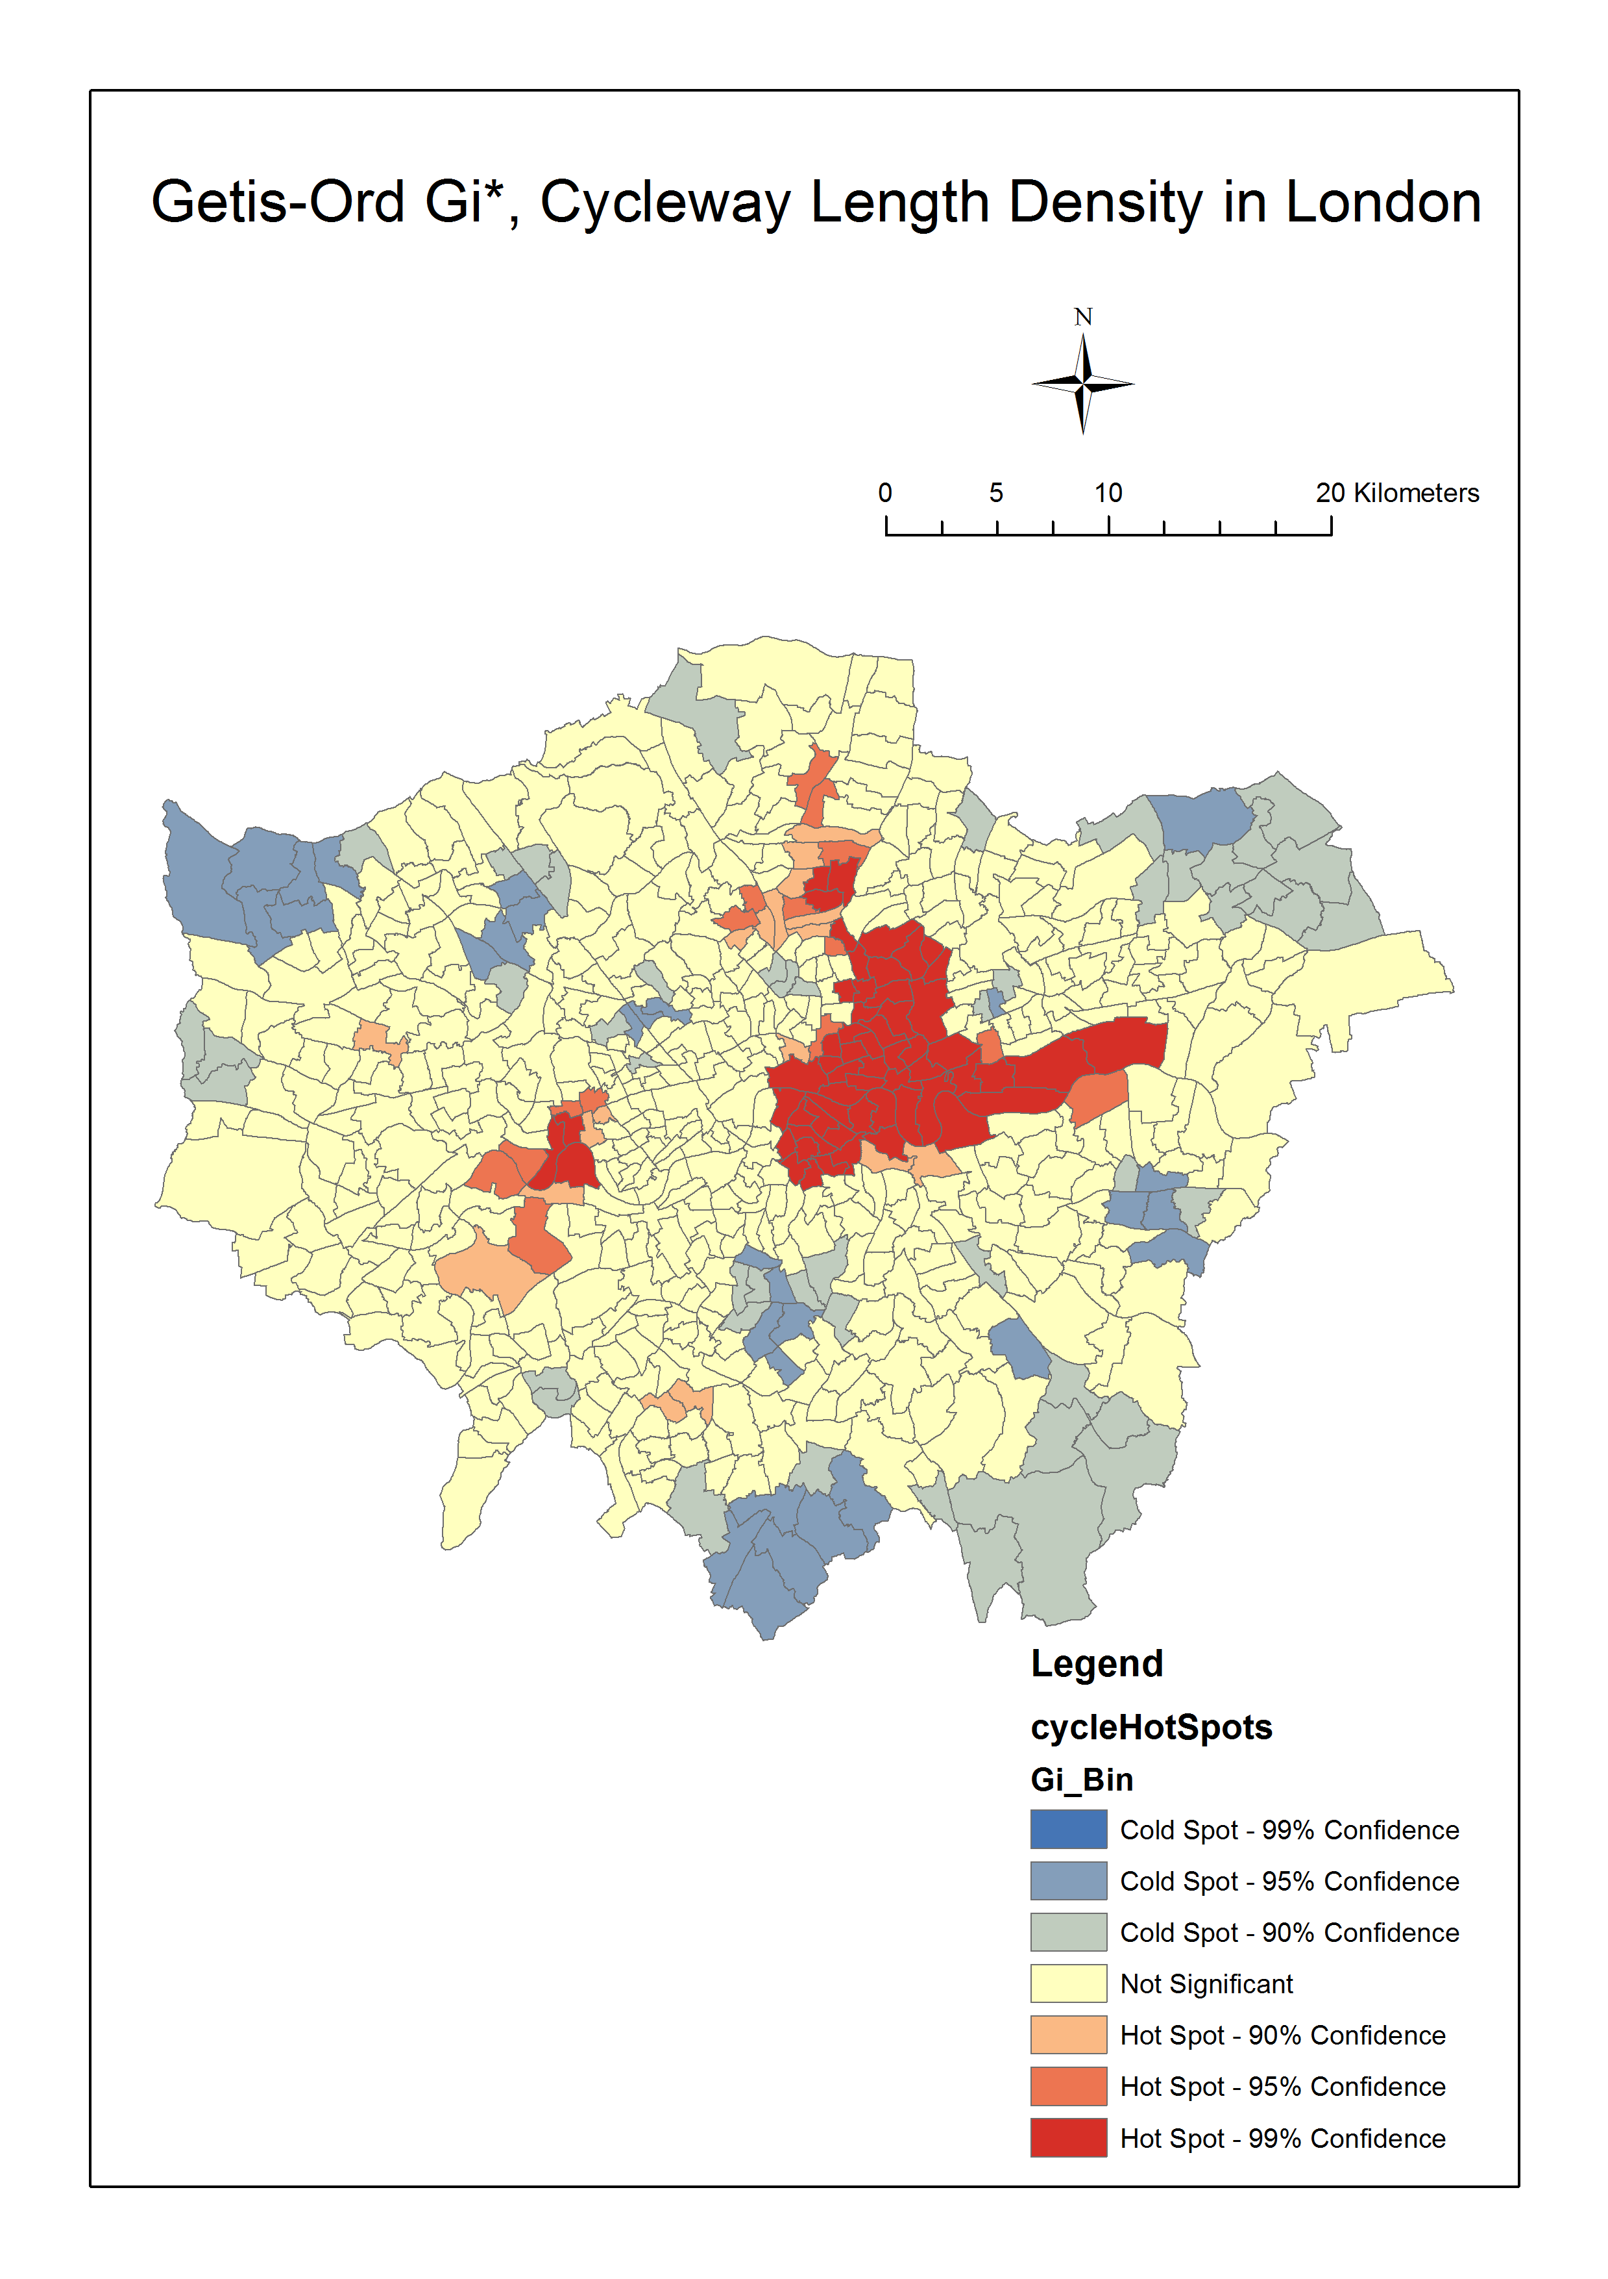

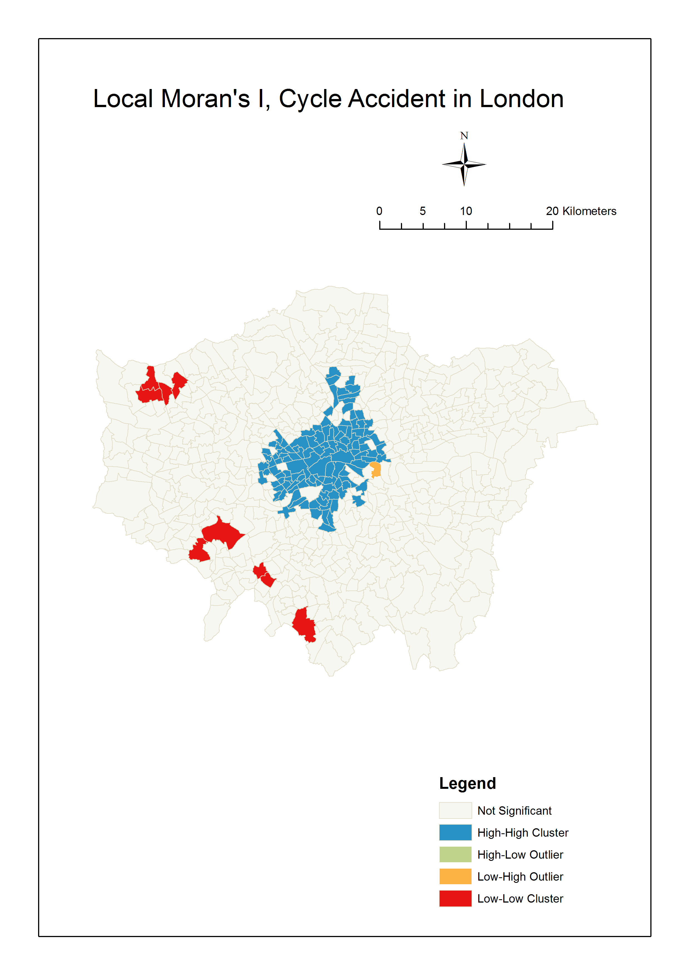

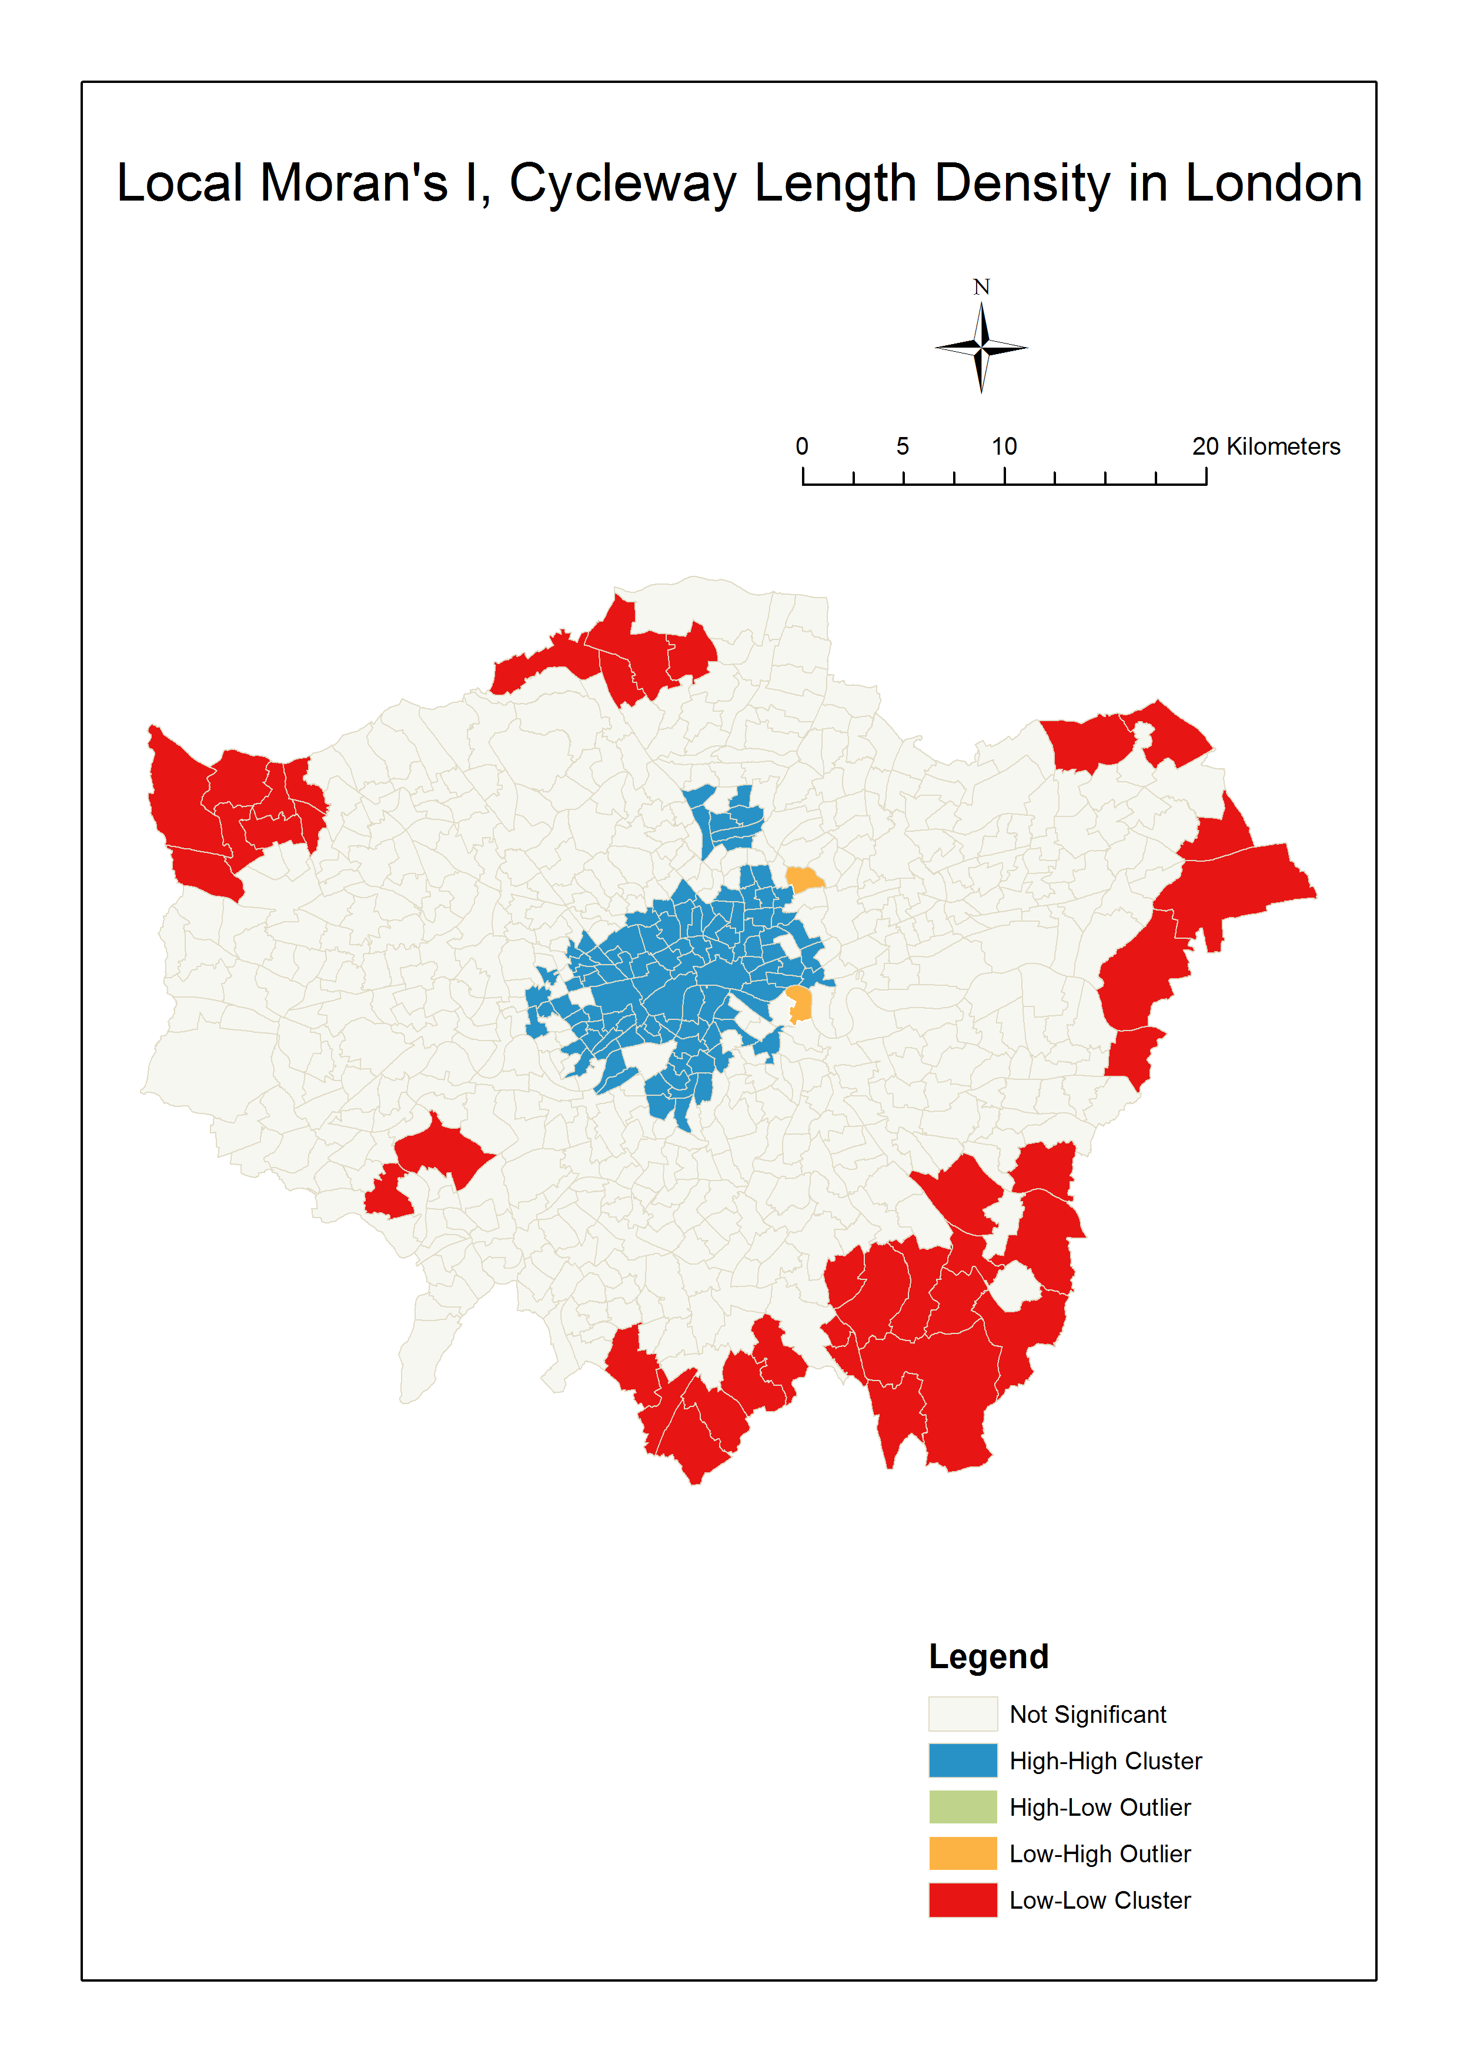

To analyze the linear relationship between the cycle accident density and the cycleway length density in every ward of London, the result of Ordinary Least Squares Analysis shows that the p-value is 0.000002 < 0.01, which means the liner relationship exists in 0.01 significant level. However, adjusted R-Squared is only 0.035, which means the cycleway length density can explain about 3.5% of the density of cycle accident. The coefficient of the equation is 0.00551, which is different from our mind, as we usually think the increase of the length of the cycleway will reduce the bicycle accidents.

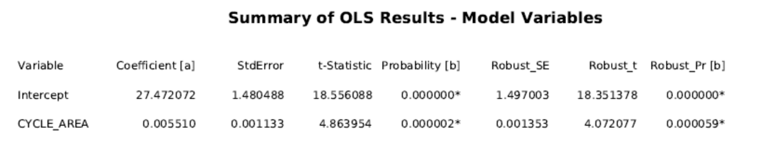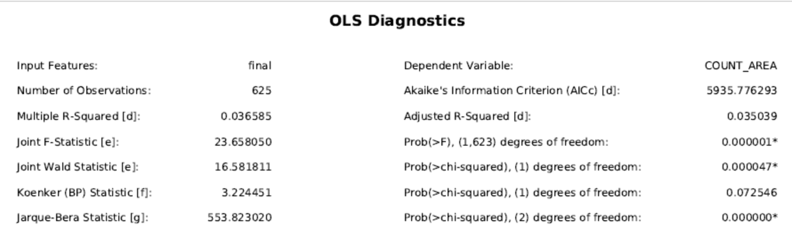

All of Variable Distributions and Relationships Plot, Histogram of Standardized Residuals and Residual vs Plot show that the relationship between them may not be linear, but more like logarithmic or exponential.

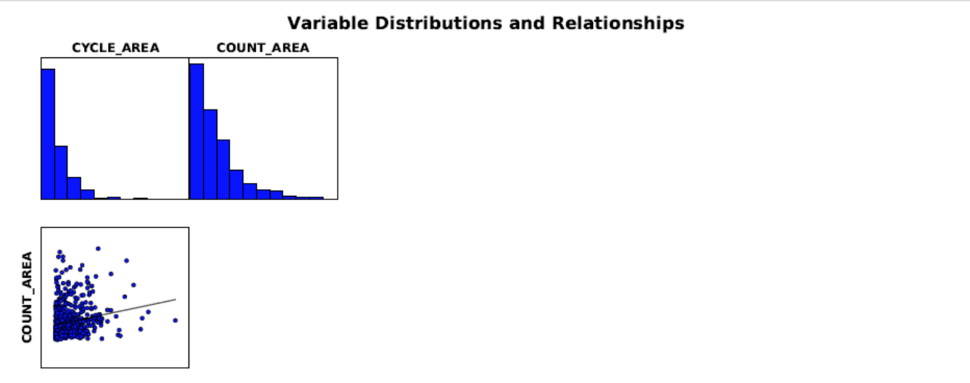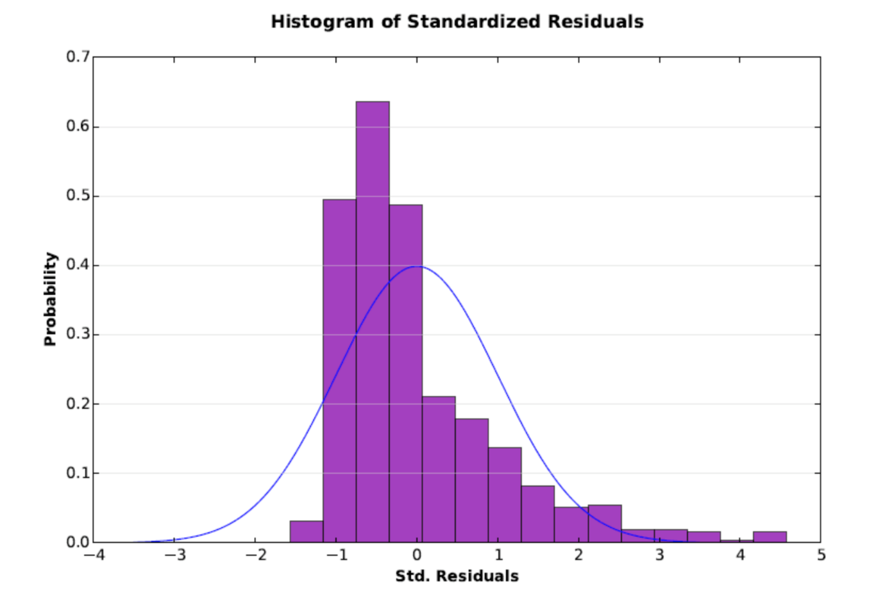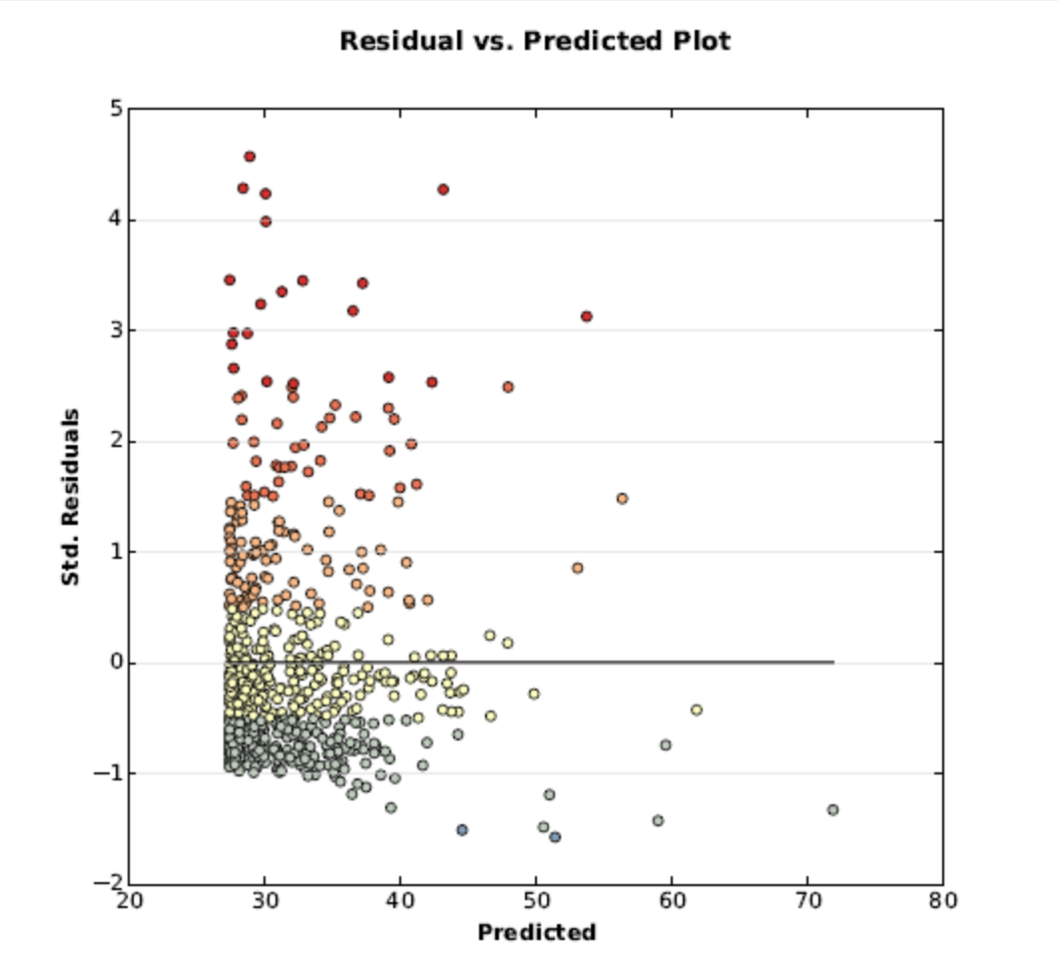

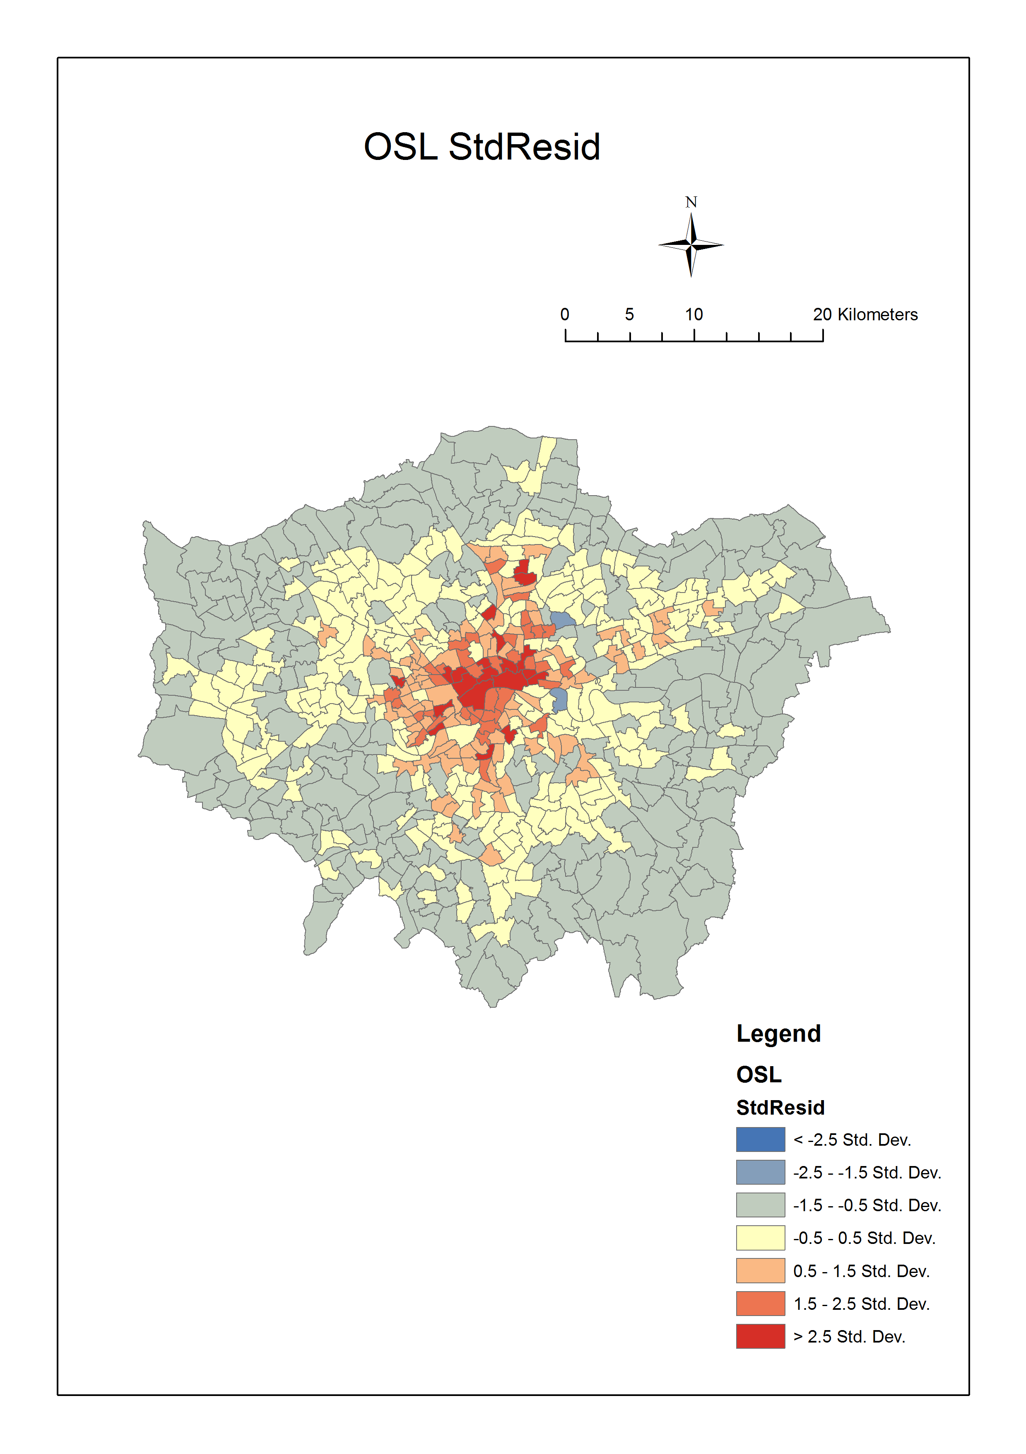

The Std. Residual map also reflect that there are many residuals cannot be explained by cycleway length density, especially in the center of London.

In further research, we can try to use nonlinear regression to analyze the relationship between the cycleway length density and the cycle accident density. We can attempt to build multiple regression model as well, as the car flowrate and bicycle flowrate, and many other variables may contribute to the cycle accident density. Spatial difference may also exist between inner London and outer London, as the residual map shows the Std. Dev of residuals in inner London are much larger than outer London. The Getis-Ord Gi* map for cycleway length density in every ward of London also seems very interesting, as the hot spots are not in the center, but inclined to the east. The reasons behind the map can be analyzed in the future.

Also, there exist many uncertainty in this research. For data, the cycleway data from OSM probably has bias and pretty different from the real world as no one will draw the cycleway systematically for no money. The people decisions in real world are also much more complex than data model, if this road has no cycleway, the cyclist may choose another way which has cycleway though the trace will be longer, as a result, the influence of whether a road has a cycleway is not so important as our imagination. What’s more, when you ride in a road without cycleway, you will really feel dangerous and may because you feel more nervous and became more careful, the probability of accident decrease. We also omitted the slight casualties when analyze the data. If we consider them together with fatal and serious casualties, they result may change a lot. The occurring of cycle accident may also been casual, cannot be explained by other variables well to some extent actually. Also, for MAUP, the choice of using wards as boundaries may not be the best decision either.

To conclude, it’s still important to improve the cycleway for cyclists though it has low relationship with road safety, as it’s a very natural-friendly and healthy ways for transportation. Wishing in the future, more data can be open to public so that the analysis for the real world can be more easily.